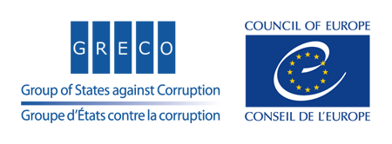

Strasbourg, 5 March 2021
Under embargo until 15 April 2021 at 10.30 am CEST (Strasbourg time)

Greco (2021)1-fin

Twenty-First General Activity Report (2020)
of the Group of States against Corruption
(GRECO)

Anti-corruption trends, challenges and good practices in
Europe & the United States of America

Feature article | By Justice Commissioner Didier REYNDERS  European Commission

Adopted by GRECO (written procedure ended on 5 March 2021)

Contents
INTRODUCTION BY THE PRESIDENT 3
Marin MRCELA, Vice-President of the Supreme Court of Croatia, President of GRECO 3
KEY FINDINGS 6
FEATURE ARTICLE 15
By Justice Commissioner Didier REYNDERS, European Commission 15
FRAMEWORK FOR GRECO’S ONGOING WORK 17
5th EVALUATION ROUND - PARAMETERS 21
GOVERNING STRUCTURES AND MANAGEMENT 22
APPENDICES 23
Appendix 1 - GRECO’S Mission 23
Appendix 2 - 4th Round Implementation Statistics 24
Appendix 3 - 5th Round Implementation Statistics 40
Appendix 4 - Core Programme 41
Appendix 5 - GRECO Delegations (at 17/12/2020) 42
Appendix 6 – Working Together for Greater Impact 54
Appendix 7 - GRECO Secretariat 57
MEMBERSHIP 58

INTRODUCTION BY THE PRESIDENT

Marin MRCELA, Vice-President of the Supreme Court of Croatia, President of GRECO

As in previous years, this report highlights the main trends drawn from GRECO’s evaluations and recommendations. It also presents examples of good practices, and shows the situation as regards the level of implementation of GRECO’s recommendations by our member states.

2020 was regrettably very much affected by the COVID-19 pandemic. As countries face undeniable emergencies, concentration of powers, derogations from fundamental rights and freedoms, and as large amounts of money are infused into the economy to alleviate the crisis (now and in the near future), corruption risks should not be underestimated. It is therefore most important that anti-corruption is streamlined in all COVID-19, and more generally, pandemic-related processes. To this end, I issued detailed Guidance for states on managing corruption risks in the context of COVID-19 and I call upon all our member states to follow them closely. It is crucial that, in state of emergency situations, all decisions and procedures are designed with transparency, integrity and accountability.

The COVID-19 pandemic has also had an undeniable impact on GRECO’s work. Since the start of the pandemic, it has not been possible for countries to host a GRECO evaluation team for an onsite visit, and no visits were carried out in 2020. The onsite dimension of GRECO's monitoring is indispensable for our assessments. While pandemic-related restrictions apply, we have made it a priority to look into possibilities of organising our work in such a way as to enable evaluation visits to resume, and we will plan a move back to onsite visits as soon as restrictions are lifted. This may be complex but should be feasible with proper preparation and a dose of good will on all sides.

That said, the COVID-19 pandemic has not prevented GRECO from holding two of its three plenary meetings and adopting evaluation, compliance and ad hoc reports. While nothing can replace the in-person meetings and discussions, GRECO was able to meet remotely and adopt six evaluation reports, twenty-eight compliance reports and one ad hoc follow-up report. Despite the circumstances, GRECO has been the most prolific anticorruption body at international level.

Even if GRECO did not carry out any ad-hoc (Rule 34) evaluations in 2020, it did follow up on the ad-hoc evaluations it had conducted in previous years and was quick to react to various developments in its members states. For example, I wrote to three member states in 2020 drawing attention to the need to comply with the relevant Council of Europe standards. These letters are public and have produced, by and large, positive effects.

The 5th evaluation round is fully underway and by the end of 2020 a total of 21 5th round evaluations had been carried out. This round focuses on corruption prevention in central governments, including the top executive functions, and law enforcement. Needless to say, this round tackles the core of the functioning of the executive branch in our member states and it is very important for countries to implement fully and without delay our recommendations. I wish to draw your attention to the fact that GRECO agreed to have a slightly different compliance process for the 5th round. The procedure, which is transparently reflected now in our Rules, will allow countries time for deep reforms and “decongesting” GRECO’s compliance work in the medium term.

The positive trend of member states authorising the publication of GRECO’s reports has continued and is invaluable as a means of raising awareness about the issues examined by GRECO and the solutions that member states adopt in order to implement GRECO’s recommendations. I can only encourage all member states to follow this practice.

2020 was also a year of growth for GRECO, both in terms of participation and in terms of budget. On the latter, I wish to thank the Statutory Committee for their continuous, strong support for our work. On the former, 2020 saw the membership of Kazakhstan as GRECO’s 50th member state, the participation of the European Union as an observer, and renewed interest by Tunisia which, as you will remember, was invited by the Committee of Ministers to join GRECO already three years ago.

Last but not least, 2020 confirmed the centrality of GRECO’s work to ensure respect for the Rule of Law in Europe. It is clear by now that creating specialised institutions or adopting new laws will not, in and of itself, improve countries’ ability to prevent and combat corruption. We need to see effective implementation of these standards, by all those with a responsibility, and this is one of the areas GRECO is increasingly focusing on. When looking at the measures to prevent corruption, we must bear in mind that we should not see the fight against corruption as separate from, or even opposed to, judicial independence. The first is absolutely essential to the second, and vice-versa. It would be a great misconception to start thinking that judicial independence can be curbed under the pretext of fighting corruption in the judiciary.

Judicial independence is a cornerstone of a democratic society based on the principles of Human Rights and the Rule of Law promoted by the Council of Europe. This notion has been extensively discussed by the European Court of Human Rights in its case-law and by GRECO. Other Council of Europe bodies have also interpreted it in depth. I deeply regret that in some of our member states – across our membership – we continue to see more or less conspicuous attempts by the other branches of power (the executive and/or the legislative branch) to attack, intimidate or subjugate the judiciary. GRECO has reacted and will continue to react to stop such attempts.

In that respect, I fear that I must repeat myself: senior political leaders need to lead by example. In a number of our member states – both in Europe and in the United States – this has not always been the case. Attacking the judiciary and law enforcement or using them for partisan political purposes, silencing or harassing journalists or anyone who has a different view, vowing to replace institutions politicians disagree with, undermining whistle-blowers, ignoring the most basic rules of ethics and, at times, of decency, spreading “fake news” and taking advantage of social media to multiply the message, are all examples of situations we have witnessed in 2020. We need governments to act in line with the standards that have united us for the past 70 years and GRECO’s 5th evaluation round is key in reminding GRECO member states of their commitments and highlighting the best course of action in many of these areas. In this regard, I am grateful to the Council of Europe’s Secretary General for devoting an entire Chapter of her Report on the State of Human Rights, Democracy and the Rule of Law in Europe to the “integrity” of institutions.

GRECO has continued to attach great importance to ensuring cooperation and synergies with the other international anti-corruption monitoring bodies in the United Nations (UN), the Organisation for Economic Co-operation and Development (OECD) and the Organization of American States (OAS), within the boundaries of our respective statutory requirements. We have continued to coordinate meetings and evaluation dates, exchanged information, and organised joint events where possible. GRECO adopted a Declaration to the Special Session of the UN General Assembly on Anti-Corruption and I call upon all our 50 member states to make sure that our inputs are duly reflected in the final political declaration. GRECO also cooperates with the G20 Anti-Corruption Working Group. GRECO evaluations and compliance reports feature highly in the first European Commission Rule of Law Report, as reflected in Commissioner Reynders article featured in this Report, and we stepped up cooperation with the OSCE, both its governmental and parliamentary sides.

Mainstreaming gender in all policies and measures is one of the objectives of the Council of Europe Gender Equality Strategy. For GRECO, this goal remains important to its monitoring work. A number of countries continue to receive recommendations on this topic in the context of our 5th evaluation round, for instance requiring them to achieve better gender balance in higher responsibility posts in law enforcement.

I wish also to mention the pioneering education module on anti-corruption we have developed with the “Federation for EDucation in Europe” (FEDE), an INGO with participatory status with the Council of Europe. The module forms part of FEDE’s course on European Culture and Citizenship and is being taught across FEDE’s network of higher and vocational educational institutions at 150 higher and vocational institutions in Belgium, France, Spain, Switzerland and Luxembourg (as well as various institutions in Morocco, Algeria, Ivory Coast, Senegal, Burkina Faso, Gabon and Congo). By end 2020 more than 3 000 students had taken the course and corresponding exam at bachelor's level. The module allows students to understand the social, economic and political impact of corruption, familiarising them with different forms of corruption, its causes and consequences, measures to fight corruption and international standards. I encourage all our member state governments to make use of this module and to devote due attention in schools to the need to fight corruption. Our battle against corruption should start at the earliest stage - even in kindergarten - when mentalities are formed and values can be transmitted and internalised. I hope to widen further our work in this area by developing a curriculum for younger pupils in the future.

To conclude, on behalf of GRECO, I warmly thank the authorities of Belgium and Sweden for the generous voluntary financial contributions made in 2020 in further support of our work.

KEY FINDINGS

While impacted by the COVID-19 pandemic, GRECO’s core evaluation work remained strong in 2020. GRECO adopted six evaluation reports, twenty-eight compliance reports and one ad hoc (Rule 34) follow-up report. Regrettably, since the beginning of the pandemic, no onsite visit could be carried out.

4th Round – Evaluation and Compliance

The compliance process in the 4th Evaluation Round was in full swing in 2020 (see Figure 1). Through the adoption of its 4th Round compliance reports, GRECO continued to push for the implementation of a solid body of recommendations to strengthen the prevention of corruption in respect of members of parliament, judges and prosecutors. The key findings and conclusions of the 4th Evaluation Round were summarised in a study entitled Conclusions and Trends: Corruption Prevention in respect of Members of Parliament, Judges and Prosecutors (2017). In addition, three new evaluation reports were adopted in respect of member states that joined GRECO more recently (Belarus, Liechtenstein and San Marino).

Figure 1 Implementation of 4th Round recommendations by GRECO member states 2019 - 2020
All assessments made public by end 2019 – 42 member states
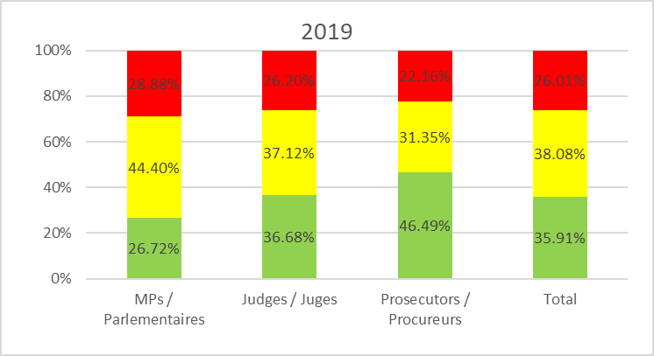
All assessments made public by end 2020 – 46 member states
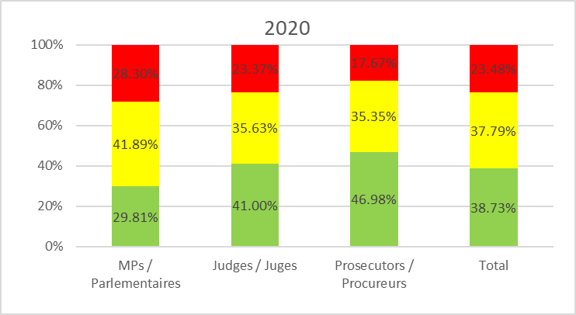

 | Implemented |  | Partly implemented |  | Not implemented
 | Mise en œuvre |  | Partiellement mise en œuvre |  | Non mise en œuvre

5th Round – Evaluation and compliance

GRECO’s 5th Evaluation Round deals with two categories: central governments, including persons with top executive functions (PTEFs), and law enforcement. The two groups selected by GRECO are different in scope and powers, yet their ability to maintain and demonstrate integrity, as well as their capacity to cope with their internal corruption-related risks are vital for the proper functioning of democracies based on the fundamental values of the Rule of Law and the protection of Human Rights.

Setting the proper tone should start with those with top executive functions who should lead by example when it comes to integrity. Irrespective of differences in the form of government and traditions, GRECO focused on the following major topics:

- Anticorruption and integrity policy, regulatory and institutional framework
- Transparency and oversight of executive activities of central government
- Conflicts of interest
- Prohibition or restriction of certain activities
- Declaration of assets, income, liabilities and interests
- Accountability and enforcement mechanisms

Anticorruption and integrity policy, regulatory and institutional framework
PTEFs need to be included in existing integrity policies. GRECO recommended to analyse and mitigate the risks this group of officials is exposed to and to build monitoring and compliance measures to help them achieve and be seen to achieve better progress in preventing corruption and instilling integrity. Most of the countries evaluated so far were asked to adopt codes of conduct for PTEFs or to revise them. Many of them were advised to adopt or consolidate in a single document policies or standards, providing clear guidance on conflicts of interest and other integrity related matters.

In some of the countries evaluated, the scope of PTEFs subject to the provisions of the code of conduct had to be broadened to include, for instance, political advisers or senior civil servants appointed to political positions. Much emphasis was put on the enforcement of such codes, in particular with effective supervision mechanisms (with possible sanctions), coupled with confidential counselling and regular and compulsory training. Many of the general issues mentioned under this topic (e.g. on lobbying, gifts and conflicts of interest) were moulded into more detailed recommendations under the other themes, hence reinforcing the need for a more holistic approach in this area.

Transparency and oversight of executive activities of central government
Access to information and transparency of the law-making process are still areas that have required GRECO’s intervention, despite the numerous recommendations that countries received in the past. GRECO had to recall the overall principle of transparency of public documents and that this should be guaranteed in practice. It has been reiterated that any exceptions to the rule of public disclosure should be limited to a minimum and that outcomes of public participation procedures should be public information. Public scrutiny is key also with respect to public procurement, in particular concerning large public contracts, and therefore should not be under-estimated.

Against this background, GRECO issued recommendations to many countries relating to the absence of rules or guidance on how PTEFs should engage with lobbyists or third parties seeking to influence the public decision-making process. Many countries were advised to ensure transparency in this area, asking them to require disclosure of such contacts and sufficient details of the subject matters discussed. Moreover, reference must be made to informal contacts that happen outside the workplace whenever a PTEF is asked, because of his/her official capacity, for a favour, or special access to information, meetings, etc. The European standard in this area is the Committee of Ministers Recommendation on the legal regulation of lobbying activities in the context of public decision making (2017).

Building on the recommendations it issued in its First and Second Evaluation Rounds, GRECO returned to access to information and transparency of the law-making process in its Fifth Evaluation Round. It would appear that there is still a broad margin of discretion for determining what is in the public domain and whether to exclude a certain document from free access. GRECO was concerned that some members were being restrictive in the application of Freedom of Information Acts (FoIA) requirements. Some agencies showed a certain reluctance to disclose information, preferring rather to apply exceptions in order to withhold all or parts of information. The application of FoIA is, more often than is desirable, inconsistent across government entities, which suggests the need to develop targeted training to create a more common understanding and application of the law. In this context, GRECO reminded countries of the standard set by Committee of Ministers recommendation Rec(2002)2 on access to official documents, which inter alia provides that limitations to the right of access to official documents should be necessary in a democratic society, proportionate and only applied if there is not an overriding interest in disclosure. Similar provisions are included in the Council of Europe Convention on Access to Official Documents (CETS No. 205), which entered into force towards the end of 2020. GRECO encouraged its member states who have not done so already to ratify this Convention.

Conflicts of interest
Effectively managing real, potential or perceived conflicts of interest is key to preventing corruption. For a majority of the countries evaluated thus far, GRECO recommended improving the management of conflicts of interest, including those arising on an ad hoc basis, in particular by clearly defining the rules and procedures that apply. It insisted that a requirement of ad hoc disclosure be introduced in respect of persons exercising top executive functions in situations of conflict between their private interests and official functions when they occur. Rules about conflicts of interest should also cover political advisors, non-remunerated “supernumerary advisory employees” and unpaid advisors in central government.

Much emphasis was placed on advisory, monitoring and compliance mechanisms. The system for managing conflicts of interest should be supplemented with clear provisions and guidance regarding (i) a requirement upon persons exercising top executive functions to disclose conflicts ad hoc and (ii) clear procedures, responsibilities and deadlines for solving situations of conflict of interest, including following complaints by the public or by other institutions.

Prohibition or restriction of certain activities
Incompatibilities, gifts, misuse of confidential information and restriction of post-employment activities were thoroughly assessed by GRECO. With regard to secondary activities, many countries were asked to review their existing rules and spell out in greater detail the activities that can be exercised by PTEFs and those which should be excluded, as well as to regulate the process for notification/asking permission. In relation to gifts and other benefits, GRECO reiterated the importance of strict limitations, highlighting the risk of “favours” being exchanged in situations where there is excessive “cosiness” between politicians and the business community.

Many of the countries reviewed were also advised to improve the situation with regard to the mobility of PTEFs from the public to the private sector (so-called “revolving-doors”), and vice-versa. For instance, GRECO recommended developing general guidelines to address the conflicts of interest that can arise from former private activities when an individual comes into government service as a top executive official and when a person entrusted with top executive functions is negotiating for a new position outside of government service if the negotiations occur before leaving public office.

Declaration of assets, income, liabilities and interests
Despite multiple attempts to introduce financial disclosure obligations as a tool of transparency, a number of deficiencies remain with regard to the scope of persons covered by this requirement, the timely publication of declarations and most importantly, with regard to their scope and independent and systematic monitoring. State secretaries and political advisers should be subject to the same disclosure requirements as ministers. It was recommended to almost all the countries evaluated to consider widening the scope of declarations of interests to include information on spouses and dependent family members.

Declarations should be subject to a review. A formal system for review of the declarations of ministers and disclosures by other PTEFs should be established or enhanced. GRECO stressed that (i) enforceable sanctions should be enacted for failing to file or knowingly making false statements in the disclosure reports; (ii) a formal system for review of the declarations of PTEFs should be established; and (iii) the reports filed should be used for counselling purposes regarding the application of the rules dealing with disqualification, outside activities and positions, and gifts.

Accountability and enforcement mechanisms
PTEFs should lead by example in matters of integrity. With that in mind, GRECO issued a series of recommendations relating to accountability and the enforcement of anti-corruption measures, for example to strengthen public integrity bodies and equip law enforcement with the proper means to conduct inquiries and investigations. GRECO stressed that codes of conduct for PTEFs would benefit from a robust mechanism of supervision and enforcement. It also pointed out that the outcome of procedures undertaken in respect of persons entrusted with top executive functions should be made known to the public. In some instances, GRECO encouraged law enforcement to be more proactive in dealing with suspected offences by PTEFs and start investigations on the basis of reasonable suspicion rather than irrefutable evidence. In several instances, GRECO reiterated its recommendations given during the 1st Evaluation Round with regard to making it possible for law enforcement, subject to judicial authorisation, to use special investigative techniques.

Immunity should not result in impunity. More than fifteen years after the subject of immunities was dealt with in GRECO’s 1st Evaluation Round, GRECO has still issued recommendations to some countries about the standard laid down in the Twenty Guiding Principles for the Fight against Corruption stipulating that immunities should be limited to the extent necessary in a democratic society so as not to hamper the investigation, prosecution or adjudication of corruption offences. It goes without saying that this rule also applies to criminal investigations against PTEFs. GRECO recommended limiting the privileges with respect to prosecution enjoyed by PTEFs for acts performed outside their official capacity and stressed the importance of objective and fair criteria for lifting immunities.

Law enforcement agencies have the authority and powers to tackle crime

Although bound by the hierarchical structure, they should ensure that their investigations are independent and free from any undue political or other pressure. Given their authority to enforce the law, they should be constantly aware that they are subject to the highest standards of integrity.

In respect of law enforcement, GRECO focused on the following issues:
- Anticorruption and integrity policy
- Recruitment, career, and conditions of service
- Conflicts of interest
- Prohibition or restriction of certain activities
- Declaration of assets, income, liabilities, and interests
- Oversight and enforcement

Top ranking law enforcement officers have important powers and authority, also because of the rather hierarchical organisation of the forces. Decisions affecting the career of officials can lie in the hands of superiors, a fact that is particularly sensitive if processes are decentralised (e.g. regarding appointments, promotions, bonuses, medals or awards, assignments and training opportunities, authorisation of secondary activities, but also transfers and discipline). For this reason, GRECO recommends streamlining procedures, the gathering of data at central level, and strengthening accountability, including by providing for adequate internal and external appeal channels. GRECO has also emphasised that it is imperative that superiors are able to fully understand the areas of vulnerability and set the right benchmark in reacting to ethical challenges. Visible leadership which consistently displays appropriate behaviour is key. Indeed, leading by example can decisively influence the desired behaviour of subordinates, their professionalism and the organisational culture. It must, therefore, be assured that specific on-going training is developed for managers to better equip them for providing a lead on ethics, preventing conflicts of interest and other integrity and anticorruption matters within their teams. Such training will serve both to raise awareness and reinforce ethical practice.

Anti-corruption and integrity policy
In a number of countries evaluated, GRECO recommended adopting a coordinated corruption prevention and integrity policy for the police, based on the systematic and comprehensive review of risk prone areas, which should be coupled with a regular assessment mechanism. In countries which had well-developed national anti-corruption strategies, codes of conduct and overall policy guidelines, several were asked to complement their codes of conduct with provisions on gifts, ad hoc conflict of interests and relations with third parties. GRECO also stressed that adherence to such codes should be supervised and enforced, in some cases asking for the introduction of the possibility to apply sanctions.
No enforcement of a code of conduct is possible without it being well understood and internalised. With that in mind, for almost all countries assessed, GRECO recommended having regular training on corruption prevention, integrity and conflicts of interests, conducted by qualified trainers, for all police staff, particularly including their superiors. GRECO also pointed out that all preventive tools should be explained to the public so that it is aware of the integrity standards that apply to the police so as to gain trust and support.
Organisation and accountability
To be able to perform effectively, adequate resources for law enforcement are necessary. In some instances, GRECO had to stress to the authorities that they need to ensure appropriate and adequate remuneration for their police officers. GRECO was also concerned in some instances that the necessary resources and expertise were not always allocated to allow for effective reforms of the police and their internal control structures.

GRECO also stressed that the police should have sufficient operational independence in practice from the political level, i.e. the ministry in charge of police matters, and that pertinent measures be taken in order to ensure that individual police officers comply in practice with the duty to implement the existing rules on integrity and impartiality in order to carry out their functions in a politically neutral manner.

Recruitment, career and conditions of service
GRECO recommended that the management of law enforcement careers should be driven by the principles of transparent and merit-based recruitment, promotion and dismissal, offering an objective appeal procedure, having clear criteria for motivating staff and striving for gender balance. In a few instances, GRECO recommended building or enhancing these principles, stressing that vacancies in the police should be advertised rather than candidates being “hand-picked” by means of transfers from the civil service. GRECO also pointed out that selection should be based on clear and objective criteria as opposed to subjective preferences, that no-one should unduly influence the process and that the highest superiors should not be above this rule. Moreover, GRECO stressed the importance of security checks at regular intervals throughout the careers of law enforcement staff as their personal circumstances are likely to change over time and, on occasion, might make them more vulnerable to corruption risks (financial problems arising for example as a result of a mortgage or consumer loan, divorce, the illness of a relative, the bankruptcy of a spouse, radicalisation, etc.). GRECO finally recommended improving the terms of employment in the police by designing additional measures to improve gender balance at all levels and in all sectors.

Conflicts of interest
Fairness and impartiality are paramount for all those exercising a public function; they are particularly important for law enforcement. Law enforcement personnel need to be proactive in dealing with their own conflicts of interest. For some countries, GRECO recommended having a more streamlined approach, with clear rules and oversight of their implementation.

Prohibition or restriction of certain activities
The rules are more stringent in some countries than in others in prohibiting law enforcement staff from performing any activity other than their work functions. A few explicitly prohibit law enforcement officials from performing activities which could be to the detriment of their service in the police. In most countries evaluated, GRECO issued a recommendation in relation to secondary employment for law enforcement.

In some cases, GRECO recommended a streamlined system for authorisation of secondary employment with effective follow-up. In other instances, GRECO advised to study the issue carefully to be better placed to decide if additional measures are needed to limit such activity and if so, to establish clear criteria for granting permission.

In some cases, GRECO recommended considering or, more strictly, introducing specific mechanisms for preventing and managing conflicts of interests after law enforcement officers leave their force, including examination of the practice more thoroughly in order to limit unrestricted permissions with regard to post-employment. The lack of rules on revolving doors in the public sector of some countries was already noted by GRECO in the 2nd Evaluation Round. In the case of law enforcement, GRECO underlined the risks this poses to their integrity. In this respect, GRECO referred to Recommendation No. R(2000)10 of the Committee of Ministers to member States on Codes of Conduct for Public Officials, Article 26, stating that "the public official should not take improper advantage of his or her public office to obtain the opportunity of employment outside the public service".

Declaration of assets, income, liabilities and interests
As regards the declaration of assets, income, liabilities and interests, GRECO recommended (i) introducing a robust, effective and regular system of declaration, including for top management; (ii) ensuring information is publicly and easily accessible and that the system is effectively implemented; and (iii) considering extending declaration requirements to spouses and dependent family members.

Oversight and enforcement
This topic attracted the highest level of attention from GRECO as oversight and enforcement are key to ensuring the effectiveness of law enforcement. Developing stronger risk management systems, making sure that these risks are addressed, and that oversight is in place was recommended to a few countries. Special attention was paid to preventing the risk of unauthorised access to registers and the leaking of information. GRECO looked at how solutions for preventing corruption risks in the police found in some countries could be useful to others. These include “multiple-eyes” procedures and greater gender mainstreaming. Another example is the rotation of staff in areas exposed to risks of corruption.

GRECO was particularly concerned about the issue of the so-called “blue code” (also “wall of silence”), i.e. the informal rule among law enforcement officers not to report their colleagues’ misconduct or offences. GRECO believes that transparency is an essential tool for upholding citizens’ trust in the functioning of the police authority and that it is a guarantee against any public perception of self-interest or self-protection within the profession. With that in mind, a few countries were reminded of the obligation for their police to report not just corruption but also integrity-related misconduct.

The system of investigation of public complaints needs to have enough independence to guarantee its objectivity and effectiveness. GRECO has underlined the need to strengthen safeguards to ensure that the follow-up to misconduct is truly impartial and seen as such by the public by being sufficiently transparent. In this regard, GRECO has been further supporting the Council of Europe Committee for the Prevention of Torture (CPT) standards and recommendations

The majority of the countries evaluated were given a recommendation regarding the protection of whistleblowers in law enforcement, with a special focus on the need to strengthen it and to provide dedicated guidance and training for all levels of the hierarchy. Whistleblower protection is a particularly important issue in law enforcement agencies because of the “wall of silence”. Most countries are currently upgrading their legislative frameworks for whistleblower protection. This is particularly true and relevant for EU members because of the requirement to duly transpose the recent EU Directive on whistleblower protection (2019). Implementation in this area also remains pressing. It is key that procedures and organisational arrangements are put in place/well-developed to effectively support whistleblowers, in line with Recommendation CM/Rec(2014)7 of the Committee of Ministers to member States on the protection of whistleblowers.

For the system to work in practice, it is crucial that whistleblowers trust the available mechanisms for their protection; the risk of reporting would otherwise be too high. The necessary legislative ban on retaliation should be coupled with workable remedies and relief for whistleblowers. It should also provide for adequate sanctions for those who retaliate. More can be done to promote awareness in this domain, including with a view to changing perceptions and attitudes towards protected disclosures and whistleblowers within law enforcement agencies; to this end, training opportunities must be intensified in this domain.

Selected good practice
Corruption prevention in central government (including top executive functions)

Transparency in the exercise of power – France
A public register listing areas where ministers are removed from the decision-making process for reasons of a risk of conflict of interest has been set up. This register, operational since 2018, can be consulted on the government’s website. This is good practice which contributes to the transparency of government decision-making and would gain in being extended to private office members given their role as close advisers to ministers and the President.
Risk analyses - Germany
The Federal Government Directive concerning the Prevention of Corruption in the Federal Administration requires all federal agencies (953 agencies and offices in total) to identify at regular intervals areas of activity that are especially vulnerable to corruption and to report back on this to the Federal Ministry of the Interior, Building and Community. If a brief examination points to a need for action, this process of identifying areas of especially vulnerable activity is to be followed by a risk analysis of those areas to determine whether existing safeguards (for example, staff rotation and the “multiple eyes” principle) are sufficiently effective to counter the risks of corruption, and if any further changes are to be made to the organisation, procedures and/or staff assignments in the federal agency in question. This requirement of the Directive is complemented by an obligation to apply further internal corruption prevention measures and to appoint a contact person for the prevention of corruption in each federal agency.
Codes of conduct – Luxembourg
GRECO commended the government's adoption, on 20 December 2019, after consultation of all ministries, of a new code of conduct for members of government and a code of conduct for their advisers. The entry into force of those codes – postponed so that the compliance report's conclusions could be taken into account, a commendable practice in the eyes of GRECO – will make it possible to fully implement a number of recommendations regarding persons entrusted with top executive functions.

Selected good practice
Corruption prevention in law enforcement agencies

Independent and internal investigations - Denmark
The Independent Police Complaints Authority is an autonomous government agency – independent from the police, prosecution service and Ministry of Justice – which investigates ex officio or following a complaint, criminal offences or misconduct committed by police staff, using the same investigative tools as in ordinary criminal investigations. Mandatory investigation is required in case of death or serious injury of persons arrested by the police or in their custody. Investigations by this Authority may lead to criminal prosecutions or disciplinary proceedings. This practice is notable for the importance given to the complaints about misconduct in order to foster ethical and good conduct by the police, and for the independence of this Authority, which enhances public trust in the outcome of these investigations.
Whistleblower protection: coupling legislative changes with operational implementation arrangements – Norway
Significant amendments were introduced to the Working Environment Act to better develop reporting and protection procedures for whistleblowers. By virtue of these provisions, all employees in the public and private sectors have the right to raise suspicions of misconduct in their respective organisation. The misconduct need not amount to a breach of the law but is broader as it targets any censurable activity. There are both internal and external channels for whistleblowing, and anonymous reporting is possible. Whistleblowers are protected from retaliation (onus of burden of proof on employer, right of the whistleblower to claim compensation – including for financial losses) and there is an employer’s duty of care to the whistleblower. Further, if the whistleblower is subject to retaliation by his/her employer, the individual can claim redress irrespective of the employer’s culpability. The Police issued detailed guidance on whistleblowing within the corps: Thanks for Speaking Out. The Police Directorate and the Chief Safety Officer also toured all police districts and special bodies in 2017-2018 to promote whistleblowing and to make employees aware of the available rules/guidance and reporting channels. Procedures and organisational arrangements to support whistleblowers are under further development, notably, through the appointment of Health and Safety Managers (HSE) and the setting up of assessment groups in whistleblowing cases.

Gender diversity is key in the prevention of groupthink and, in turn, of corruption. GRECO has issued a number of gender-related recommendations during the 5th Evaluation Round, so far aiming at increasing the representation of women at higher levels and ensuring their integration at all levels in the law enforcement agency in question. As GRECO has sometimes pointed out in country reports, diversity has the potential of having positive effects on the overall working environment within an institution, making it more representative of the population as a whole. Women sometimes struggle to advance to higher posts, for instance due to their deployment to “softer” policing roles, which often means ultimately that they do not have the range of experience required for promotion. Greater efforts can be made to enhance diversity at all levels (for example by making diversity a criterion in deployment decisions, by developing and applying a gender equality or diversity strategy).

GRECO’s media presence is sustained and growing. Communication (through traditional and social media) is embedded in GRECO’s work and allows information about GRECO’s recommendations in every country to be widely spread and debated. GRECO’s reports are published with the consent of the country concerned and all countries but one (Belarus) allow publication rather swiftly. GRECO’s website is increasingly consulted.

FEATURE ARTICLE

By Justice Commissioner Didier REYNDERS, European Commission

Respect for the rule of law is a necessity for protecting all other values and is of crucial importance for mutual trust between Member States, including their judicial authorities and for the effective application of EU law. It is also essential for the trust in public institutions, of citizens and businesses alike.

The fight against corruption is crucial for maintaining the rule of law. Corruption undermines the functioning of the state and of public authorities at all levels and is a key enabler of organised crime. Effective anti-corruption frameworks, transparency and integrity in the exercise of state power can strengthen legal systems and trust in public authorities. The European Commission and GRECO share the same objectives in this area – to improve the capacity of our Member States to prevent and fight corruption and to foster the implementation of standards for the rule of law.

Over the years, the European Commission has built up several instruments to help uphold the rule of law, which together make up a “rule of law toolbox”. Recently, the Commission has also considered how the toolbox should be further developed, leading to the establishment of the new comprehensive European Rule of Law Mechanism, with the Commission’s Rule of Law Report at its centre. Adopting the first annual Rule of Law Report on 30 September 2020 was an important milestone for our Union.

The Rule of Law Mechanism is a yearly process during which the Commission aims to prevent problems from emerging or deepening. It will create joint awareness of the rule of law situation across the EU and keep this topic on the political agenda. It will stimulate a permanent discussion on the rule of law, year after year. As from now on, the Commission will issue a report on the rule of law situation in the Union every year. The Commission provides its own qualitative assessment of general trends and the specific situation in all Member States, in the Report’s 27 country chapters. This unique source of information will enable a better understanding of the rule of law situation in the entire EU.

The Report contains the Commission’s assessment of both positive and negative developments since January 2019, drawing attention to emerging or deepening challenges, as well as highlighting good practices. It covers four pillars: the independence, quality and efficiency of national justice systems, the anti-corruption framework, media pluralism and freedom and other institutional issues related to checks and balances.

Regarding the anti-corruption framework, the Report’s main findings include that several Member States have adopted comprehensive new anti-corruption strategies or revised existing ones. These strategies need to be effectively implemented and continuously monitored, to ensure that real progress is made on the ground. In some Member States, measures have been introduced to strengthen the institutional capacity to fight corruption and to reduce obstacles to effective prosecution. But our monitoring also shows concerns in several Member States about the effectiveness of the investigation, prosecution and adjudication of corruption.

We have worked in close collaboration with the Council of Europe for preparing the Report, through a designated contact point, through which the Council of Europe provided valuable country-specific input for the Report. The Report has also taken into account existing instruments and expertise of the Council of Europe – in particular that of GRECO. GRECO’s expertise and the work done under the peer review process in the thematic evaluation rounds is a valuable source of information. The EU’s observer status has brought a real added value to the cooperation between the European Union and the Council of Europe. The published GRECO evaluation reports will continue to be an important source also in view of preparing future editions of the Commission’s Rule of Law Report. This also helps to ensure synergies among the various monitoring mechanisms.

The European Rule of Law Mechanism is more than the Report itself. What the Commission wants to achieve through the Report is to foster a deeper dialogue that will contribute to creating a rule of law culture throughout the European Union, to allow Member States to learn from each other and to address challenges before they are emerging or deepening.

We need such a dialogue at both the EU and at the national level: with the European Parliament and the Council, with national parliaments and national stakeholders and of course with the Council of Europe. The Commission’s goal is to allow Member States to learn from each other and to give every Member State the opportunity to further improve.

I look forward to continuing our cooperation with GRECO and other bodies of the Council of Europe for future editions of the Rule of Law Report. The Rule of Law Report marks a turning point in the European Union, and the Union will grow from this approach.

FRAMEWORK FOR GRECO’S ONGOING WORK

Anti-corruption standards of the Council of Europe

The three unique treaties developed by the Council of Europe deal with corruption from the point of view of criminal, civil and administrative law. Corruption is seen not only as a threat to international business and to financial interests, but to the values of democracy, human rights and the rule of law that are upheld by the Organisation. The Criminal Law Convention on Corruption (ETS No. 173) sets out common standards for corruption offences – among others, the establishment of criminal offences for active and passive bribery (as well as aiding and abetting in such offences) of domestic public officials, domestic public assemblies, foreign public officials, foreign public assemblies, members of international parliamentary assemblies and judges and officials of international courts; for active and passive bribery in the private sector and for trading in influence. Parties to the convention are required to provide for corporate liability, the protection of collaborators of justice and witnesses, and to establish in respect of the above offences effective, proportionate and dissuasive sanctions. An Additional Protocol to ETS No. 173 (ETS No. 191) requires the establishment of criminal offences for active and passive bribery of domestic and foreign arbitrators and jurors.

The Civil Law Convention on Corruption (ETS No. 174) deals with compensation for damage, liability, contributory negligence, limitation periods, the validity of contracts, protection of employees, accounts and auditing, the acquisition of evidence, interim measures and international cooperation in relation to corruption defined as “requesting, offering, giving or accepting, directly or indirectly, a bribe or any other undue advantage or prospect thereof, which distorts the proper performance of any duty or behaviour required of the recipient of the bribe, the undue advantage or the prospect thereof”.

Within GRECO, the same evaluation criteria and level of detailed scrutiny apply to states whether they have ratified these treaties or not. To date, all Council of Europe member states and Belarus (i.e. nearly all GRECO members) have ratified the Criminal Law Convention on Corruption (ETS No. 173). The United States of America signed it (in 2000). In 2020, Estonia ratified the Additional Protocol to the Criminal Law Convention on Corruption (ETS No. 191).

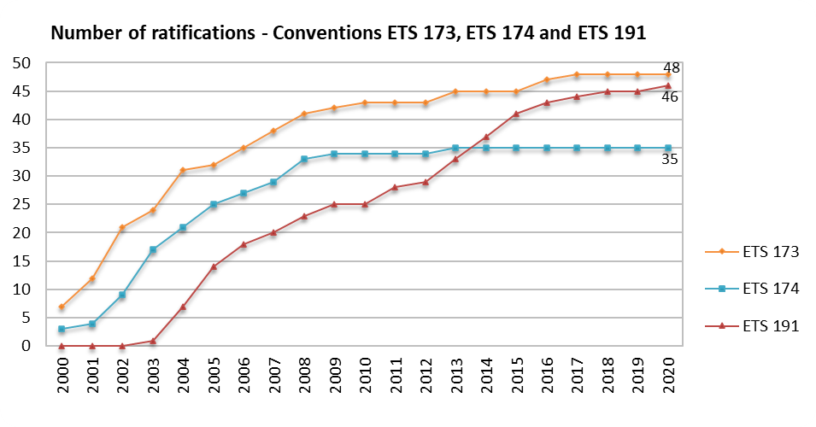

While it is welcomed that the Criminal Law Convention (ETS No. 173) and its Protocol (ETS No 191) are widely ratified, it is regrettable that at end 2020, 14 GRECO member states had still not ratified the Civil Law Convention on Corruption (ETS No. 174) despite its importance for the public, private (business) and not-for-profit sectors. The graph above shows that the impetus of the ratification process basically stalled 10 years ago and GRECO might decide in due course to revive that process e.g. through specific measures to promote the Convention, or by basing a future evaluation round on the Convention. Likewise, while it is not a treaty that GRECO evaluates, it is regrettable that the number of parties to the Council of Europe Convention on the Manipulation of Sports Competitions (CETS No. 215) remains very low (seven) even though corruption and integrity cases affecting sports events, and competition-related business more generally, have never been so frequently and prominently in the public eye.

Council of Europe Treaty Office: www.conventions.coe.int

The treaties are complemented by the following legal instruments:

- Twenty Guiding Principles for the fight against Corruption (Committee of Ministers Resolution (97) 24)
- Recommendation on Codes of Conduct for Public Officials (including a model code) (Committee of Ministers recommendation to member States No. R(2000) 10)
- Recommendation on Common Rules against Corruption in the Funding of Political Parties and Electoral Campaigns (Committee of Ministers recommendation to member States Rec(2003)4)

Furthermore, the Committee of Ministers has drawn GRECO’s attention to anti-corruption components of other legal instruments and advisory texts that it can take into account in its work, for example:

- Convention on the Manipulation of Sports Competitions (CETS No. 215)
- Recommendation on the Protection of Whistleblowers (Committee of Ministers recommendation to member States CM/Rec(2014)7)
- Consultative Council of European Prosecutors (Rome Charter) Opinion on European Norms and Principles concerning Prosecutors (CCPE Opinion No.9)
- Consultative Council of European Judges Opinions on The Position of the Judiciary and its Relations with other Powers of State in a Modern Democracy (CCJE Opinion No. 18) and The Role of Court Presidents (CCJE Opinion No. 19)
- Recommendation on the Legal Regulation of Lobbying Activities in the Context of Public Decision-making (Committee of Ministers recommendation to member States CM/Rec(2017)2)

Methodology - Evaluation

GRECO evaluation procedures involve the collection of information through questionnaire(s), on-site country visits enabling evaluation teams to solicit further information during high-level discussions with domestic key players and practitioners, and drafting of evaluation reports. These reports provide an in-depth analysis of the situation in each country and are examined and adopted by GRECO during plenary meetings. Evaluation reports state whether legislation and practice comply with the provisions under scrutiny and address recommendations to member states when action is required. The authorities are subsequently asked to report on the measures taken, which are then assessed by GRECO under a separate compliance procedure.

Methodology - Compliance

In the compliance procedure, GRECO monitors the implementation of the recommendations it has issued to the country in the evaluation report. The assessment of whether a recommendation has been implemented satisfactorily, partly or has not been implemented is based on a situation report, accompanied by supporting documents, submitted by the member under scrutiny. In cases where not all recommendations have been complied with, GRECO will re-examine outstanding recommendations. Compliance reports adopted by GRECO also contain an overall conclusion on the implementation of all the recommendations, the purpose of which is to decide whether to terminate the compliance procedure in respect of a particular member. For the 5th Evaluation Round, if at least two-thirds of the recommendations have been implemented satisfactorily or dealt with in a satisfactory manner, GRECO shall terminate the compliance procedure. The Rules of Procedure of GRECO foresee a special procedure, based on a graduated approach, for dealing with members whose response to GRECO’s recommendations has been found to be globally unsatisfactory. These Rules also include a new provision allowing GRECO to act on an ad hoc basis when an institutional reform, legislative initiative or procedural change by a member state might result in a serious violation by that member of a Council of Europe anti-corruption standard.

Evaluation Rounds

GRECO’s monitoring work is organised in rounds. Each has its own thematic scope and makes reference to a range of Council of Europe standard-setting texts of pertinence to the issues examined.

5th Evaluation Round (launched on 1 January 2017)
Preventing corruption and promoting integrity in central governments (top executive functions) and law enforcement agencies
Central government (top executive functions)
- System of government and top executive functions
- Anticorruption and integrity policy, regulatory and institutional framework
- Transparency and oversight of executive activities of central government
- Conflicts of interest
- Prohibition or restriction of certain activities
- Declaration of assets, income, liabilities and interests
- Accountability and enforcement mechanisms
Law enforcement agencies
- Organisation and accountability
- Anticorruption and integrity policy
- Recruitment, career and conditions of service
- Conflicts of interest
- Prohibition or restriction of certain activities
- Declaration of assets, income, liabilities and interests
- Oversight and enforcement

4th Evaluation Round (2012 - 2017)
Prevention of corruption in respect of members of parliament, judges and prosecutors
- Ethical principles and rules of conduct
- Conflicts of interest
- Recruitment, career and conditions of service (judges and prosecutors)
- Transparency of the legislative process (members of parliament)
- Remuneration and economic benefits (members of parliament)
- Prohibition or restriction of certain activities
- Declaration of assets, income, liabilities and interests
- Supervision and enforcement of rules and regulations
- Advice, training and awareness

3rd Evaluation Round (2007 - 2012)
Theme I: Incriminations
- Essential concepts to be captured in the definition of passive and active bribery offences as well as trading in influence
- Limitation periods
- Jurisdiction
- Special defences
Theme II: Political funding
- Transparency of books and accounts of political parties and election campaigns
- Monitoring of party and campaign funding
- Enforcement of the relevant funding rules

2nd Evaluation Round (2003 - 2006)
- Identification, seizure and confiscation of corruption proceeds
- Public administration and corruption (auditing systems, conflicts of interest, reporting of corruption and whistleblower protection)
- Prevention of legal persons being used as shields for corruption
- Fiscal and financial legislation to counter corruption
- Links between corruption, organised crime and money laundering.

1st Evaluation Round (2000 - 2003)
- Independence, specialisation and means available to national bodies engaged in the prevention and fight against corruption
- Extent and scope of immunities from criminal liability.

Members that join GRECO after the close of an evaluation round undergo evaluations on the themes of previous rounds before joining the current one, starting with the first two rounds that are restructured into Joint 1st and 2nd Round Evaluations.

Publication of reports

Raising awareness of GRECO’s findings across society prompts domestic debate and support for the implementation of its recommendations. The long-standing practice whereby GRECO member states - with rare exceptions - lift the confidentiality of reports shortly after their adoption and translate them into national languages goes well beyond what was originally provided for in the Rules of Procedure. The release of a report for publication is coordinated with the member state concerned and the Directorate of Communication of the Council of Europe to maximise media attention; this helps raise awareness in society and the institutions concerned about the expected reforms, which can in turn contribute to increasing support for their adoption and implementation. In the rare case that a country persistently refuses to authorise the publication of a report, GRECO has decided to publish a summary of it (e.g. Belarus in 2014, 2015, 2016 and 2017). In respect of the same member state, GRECO published a declaration of non-conformity in 2019.

5th EVALUATION ROUND - PARAMETERS

GRECO’s 5th Evaluation Round which was launched in 2017 is devoted to Corruption prevention and promoting integrity in central governments (top executive functions) and law enforcement agencies. Directing attention to central government (top executive functions) constitutes a logical extension to the 4th Round with its implications for shaping citizens’ attitudes vis-à-vis their political institutions and democracy in general. Furthermore, while law enforcement authorities form a cornerstone of the fight against corruption and their integrity is therefore fundamental, experience shows that the specific risk factors involved in the work of law enforcement agencies warrant careful consideration.

For the purpose of the 5th Evaluation Round, the term “central government” includes persons who are entrusted with top executive functions at national level (PTEFs). Bearing in mind each country’s constitutional set-up, these functions might include those of heads of state, heads of central government, members of central government (e.g. ministers), as well as other political appointees who exercise top executive functions such as deputy ministers, state secretaries, heads/members of a minister’s private office (cabinet ministériel) and senior political officials. This might include political advisors, depending on the system of the country. Where political advisors are not evaluated in their own right, information about their interactions with PTEFs is nevertheless examined. Prior to the evaluation, the member state concerned is requested to submit a comprehensive and precise list of the “top executive functions” exercised by the head of state and by the head of the central government.

Specifically as regards Heads of State, GRECO decided (78th Plenary Meeting, December 2017) on the following definition for the 5th Round: “A Head of State would be covered by the 5th Evaluation Round under “central governments (top executive functions)” when s/he actively participates on a regular basis in the development and/or the execution of governmental functions, or advises the government on such functions. These may include determining and implementing policies, enforcing laws, proposing and/or implementing legislation, adopting and implementing by-laws/normative decrees, taking decisions on government expenditure, taking decisions on the appointment of individuals to top executive functions.”

Concerning law enforcement agencies, in the interests of providing a streamlined, in-depth assessment, the evaluation focuses on officials of selected bodies performing core law enforcement functions who are subject to national laws and regulations – namely police services at national level which may include agencies responsible for border control. If a country has multiple police services at national level, the evaluation is limited to two or three main services, and prior to the evaluation, on the basis of a reasoned proposal by the member state concerned, GRECO determines which are to be selected.

In terms of the methodology and structure of evaluation reports, GRECO adopts a similar approach to that developed in the 4th Round. The questionnaire, which provides the main grid for evaluation, is divided into two parts: part (A) dealing with central governments (top executive functions) and part (B) dealing with selected law enforcement agencies. Both parts follow a similar structure with targeted questions under specific headings. The first section of each part serves the purpose of generating fundamental input for obtaining an overall understanding of the system in each country.

Finally, it needs to be stressed that much emphasis is put on the effective implementation of existing regulations. It is clear that effective corruption prevention relies to a large extent on the realisation of tangible achievements, and it is therefore crucial for GRECO evaluation teams to receive a maximum of information on practical and organisational arrangements, specific examples and statistics on the application of the law, training, awareness-raising and other initiatives.

GOVERNING STRUCTURES AND MANAGEMENT

The permanent bodies constituting GRECO are the Plenary, the Bureau and the Statutory Committee. The Statute also provides for ad hoc bodies, principally evaluation teams but also working parties.

Plenary and Bureau
GRECO elects a President, Vice-President and Bureau for each new evaluation round. The position of President and Vice-President for the 5th Evaluation Round were taken up, in January 2017, by Marin MRČELA, Vice-President of the Supreme Court of Croatia and, in December 2019, by Monika OLSSON, Director of the Division for Criminal Law of the Ministry of Justice of Sweden, respectively. In 2020, the Bureau was composed of the President, Vice-President, and Panagiota VATIKALOU, Presiding Judge, First Instance Court of Athens (Greece); Aslan YUSUFOV, Office of the Prosecutor General (Russian Federation); Vita HABJAN BARBORIČ, Commission for the Prevention of Corruption (Slovenia); Ernst GNAEGI, Federal Ministry of Justice (Switzerland); and David MEYER, Ministry of Justice (United Kingdom).

The representatives of member states that compose the Plenary are directly involved in the peer review process during the examination and adoption of evaluation and compliance reports. The Plenary also takes final decisions on the focus of GRECO’s monitoring, policy and planning.

Statutory Committee - Budget and Programme of Activities
The Statutory Committee is composed of the Permanent Representatives of all Council of Europe member states (the Committee of Ministers) and representatives of the GRECO member states that are not members of the Organisation (Belarus, Kazakhstan and the United States of America) . Its principal task is to adopt GRECO’s programme and budget which is prepared in line with the biennial method currently implemented throughout the Organisation and based on priorities presented by the Secretary General and on GRECO’s annual programme of work. The Statutory Committee, chaired in 2020 by Emil RUFFER, Ambassador Extraordinary and Plenipotentiary, Permanent Representative of the Czech Republic to the Council of Europe, held an exceptional meeting in February and approved GRECO’s budget for 2021 by written procedure in October.

Secretariat
The Secretariat, headed in 2020 by Gianluca ESPOSITO, Executive Secretary, provides support, guidance and technical and legal advice to countries participating in GRECO’s monitoring work and is responsible for the management of the budget and programme of activities, as well as external relations (organisational chart of GRECO’s Secretariat - Appendix 7).

APPENDICES

Appendix 1 - GRECO’S Mission

The anti-corruption monitoring body of the Council of Europe has been operational since 1999. It was established as the result of the strong political will of Council of Europe member states to take decisive and enduring measures to counter corruption by ensuring adherence to, and effective implementation of, the Organisation’s far-reaching anti-corruption standards. The mission of its membership, which extends beyond the geographical span of the Council of Europe, is to promote targeted anti-corruption action, awareness of corruption risks and careful consideration and implementation of reforms to remedy shortcomings in national policies, legislation and institutional set-ups.

The clear stated political objective of strengthening the capacity of member states to prevent and fight corruption is served by a monitoring model designed to provide each member state with a detailed analysis and set of recommendations that are tailored to the specificities of each country. Subsequent “compliance procedures” serve to verify achievements and actively push for alignment with what is recommended. Multiple layers of result validation and a high level of process ownership are salient features of this model, where the dynamics of mutual evaluation and peer pressure are brought into play.

Appendix 2 - 4th Round Implementation Statistics
Statistics covering all assessments made public by end 2020 – 46 member states

 | Implemented |  | Partly implemented |  | Not implemented
 | Mise en œuvre |  | Partiellement mise en œuvre |  | Non mise en œuvre

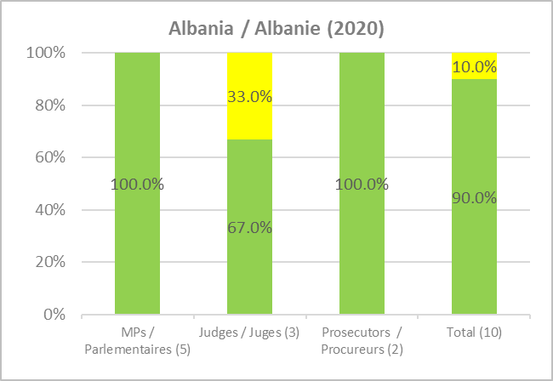

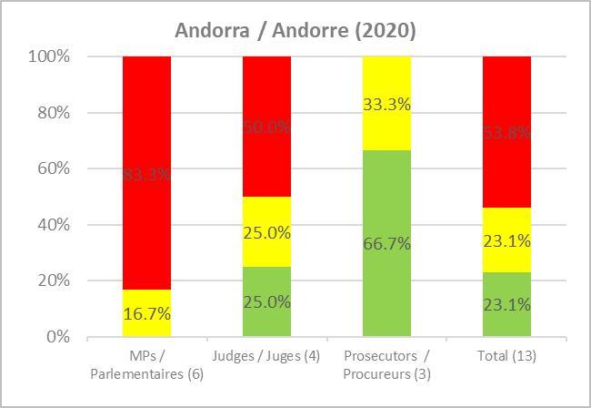

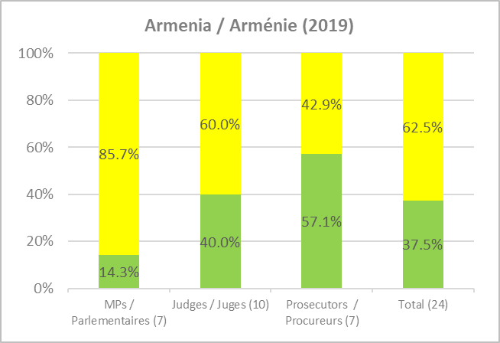

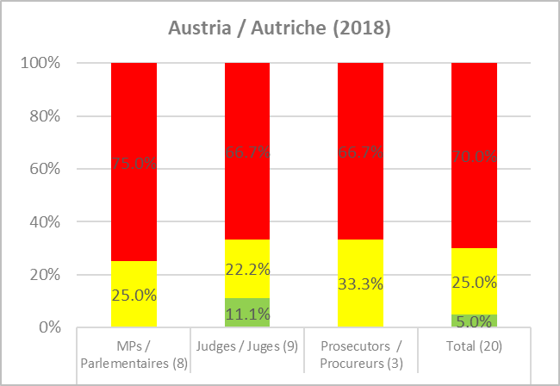

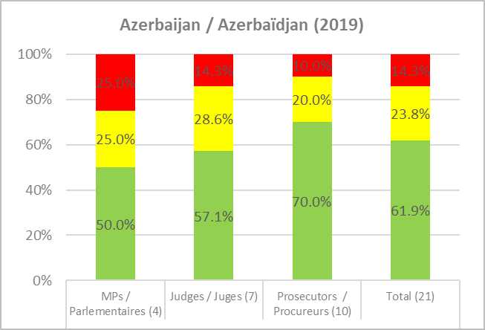

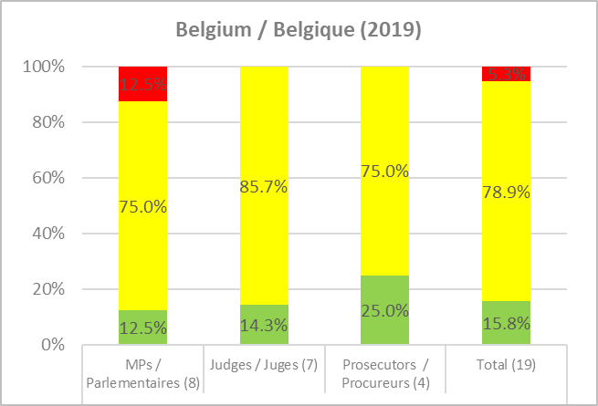

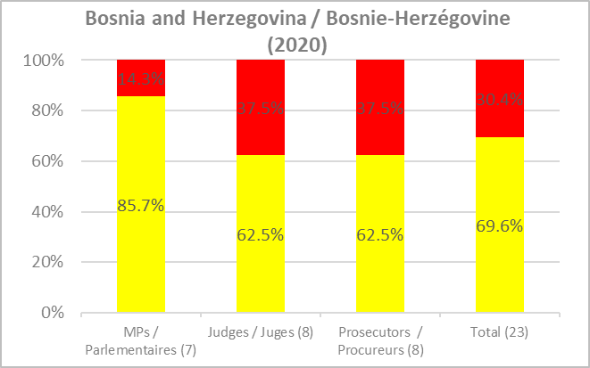

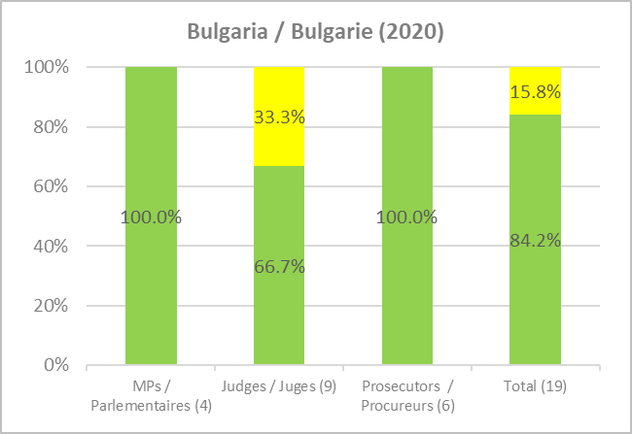

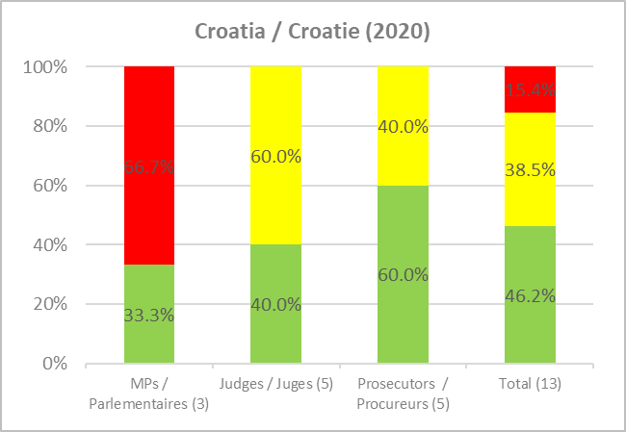

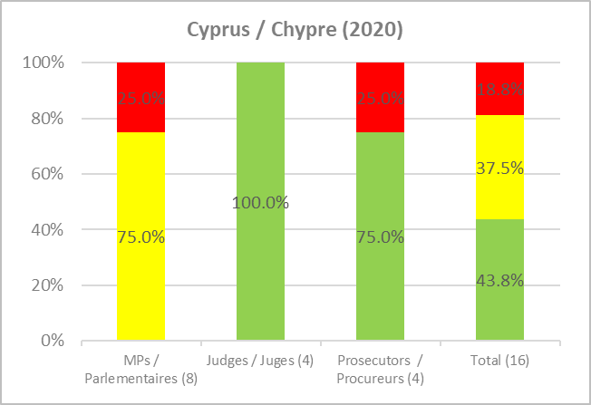

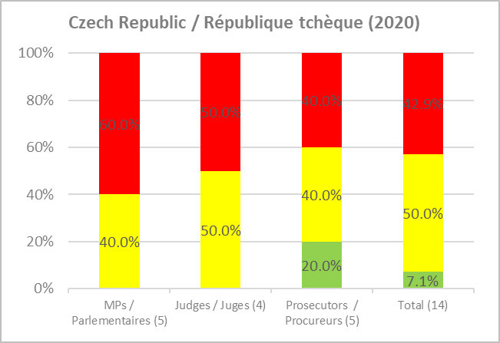

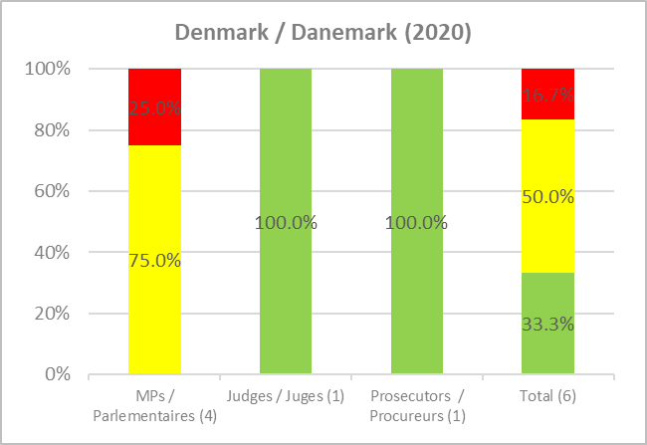

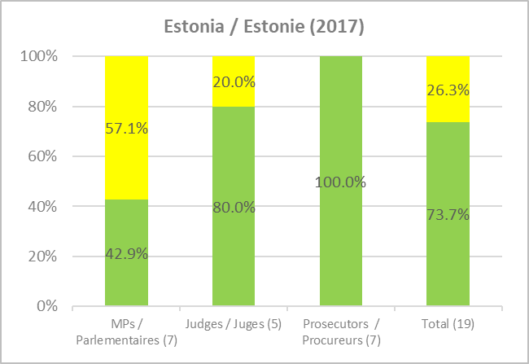

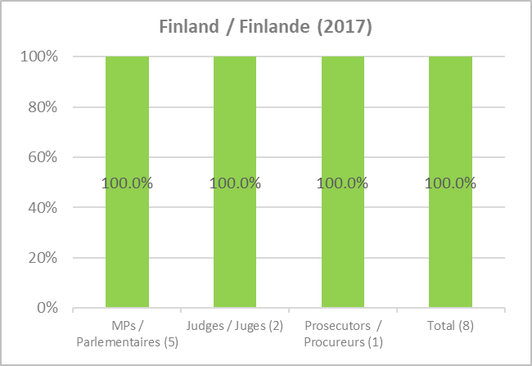

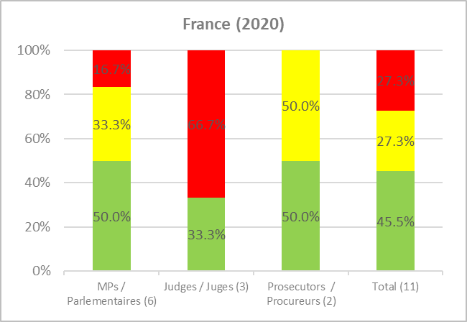

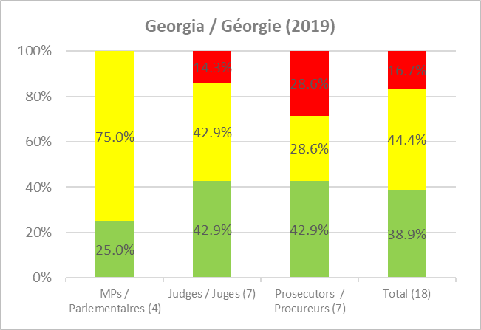

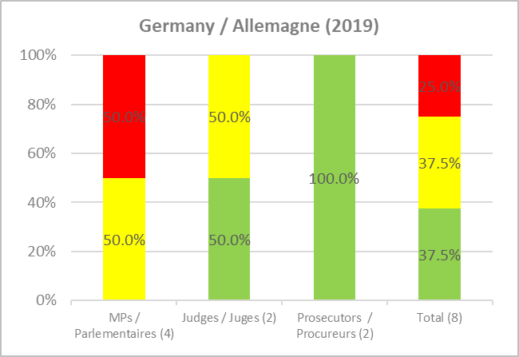

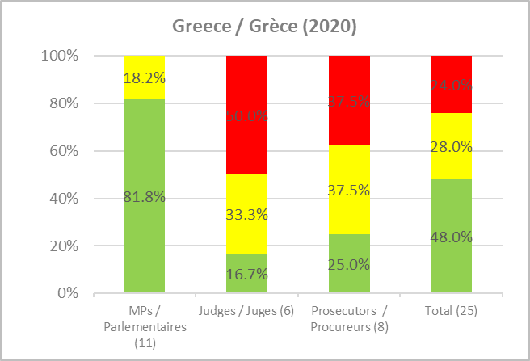

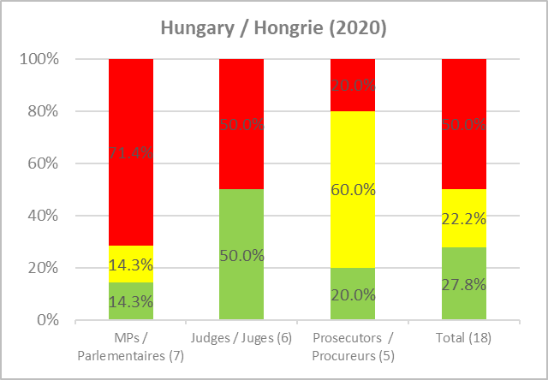

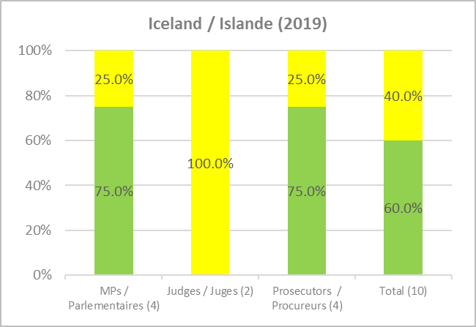

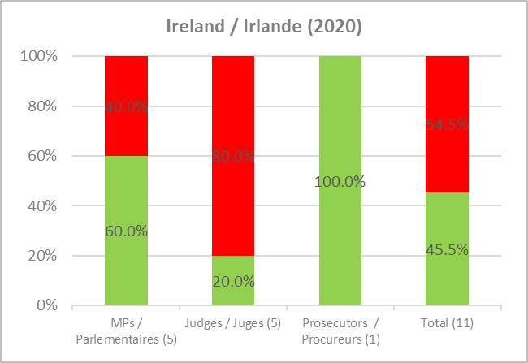

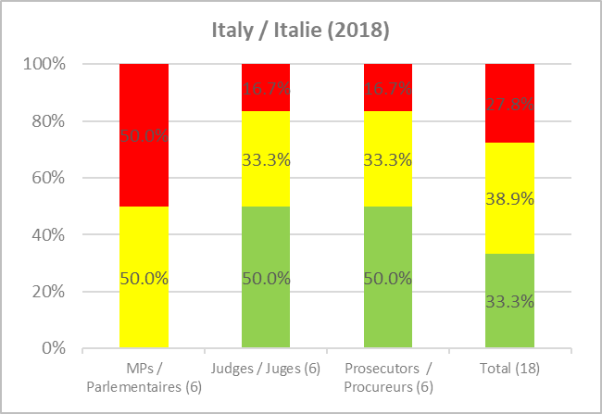

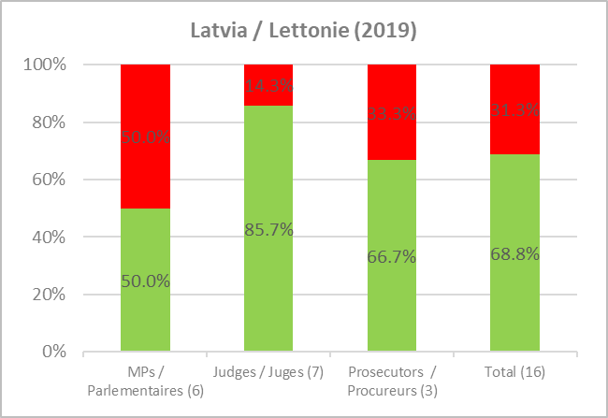

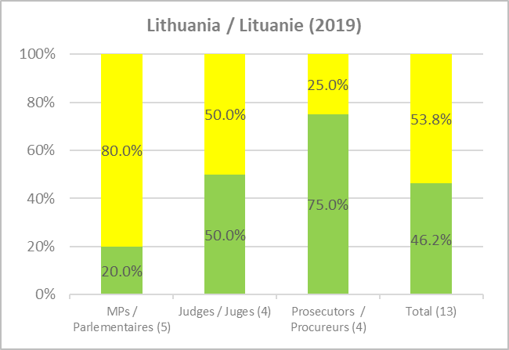

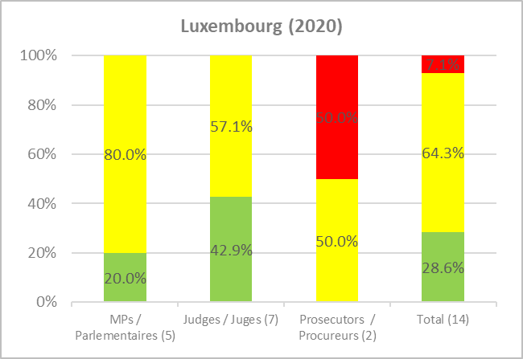

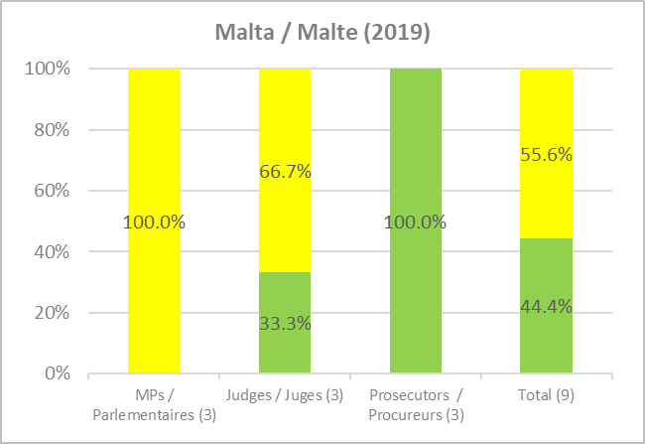

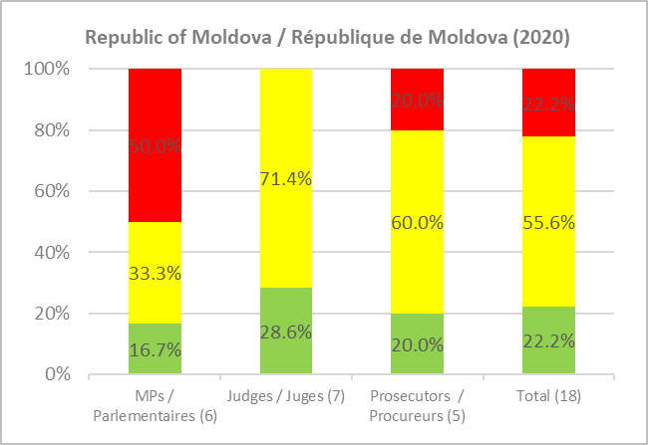

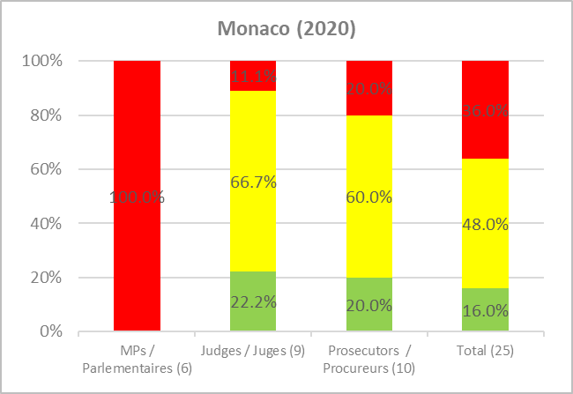

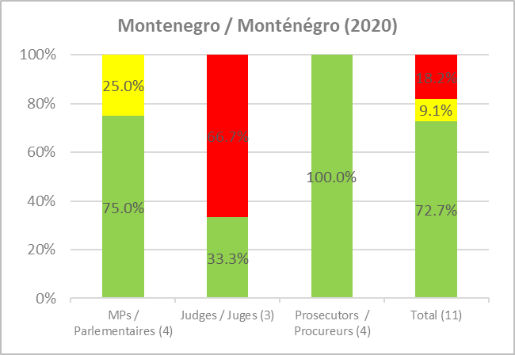

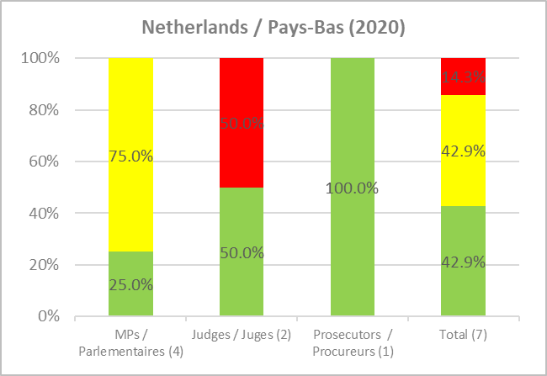

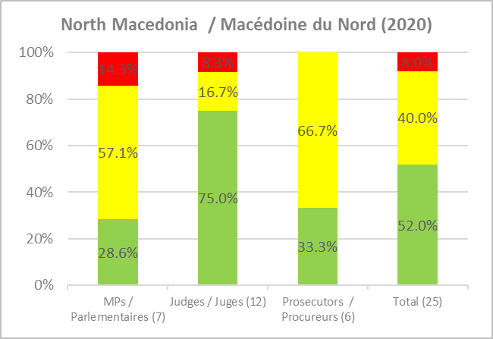

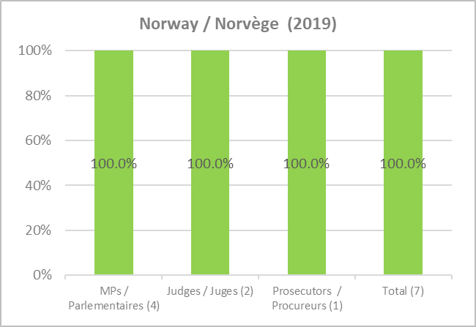

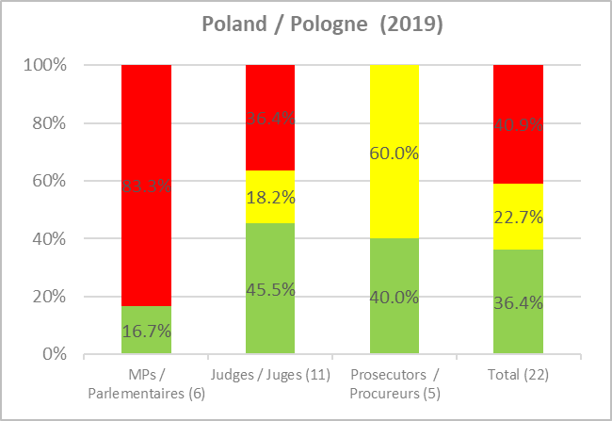

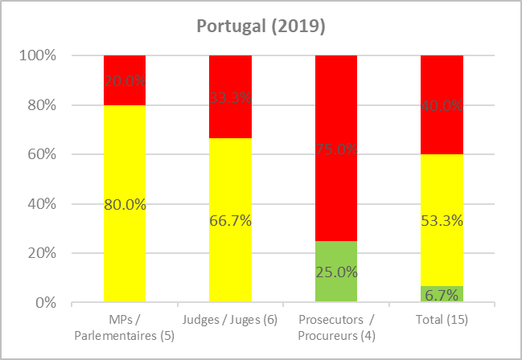

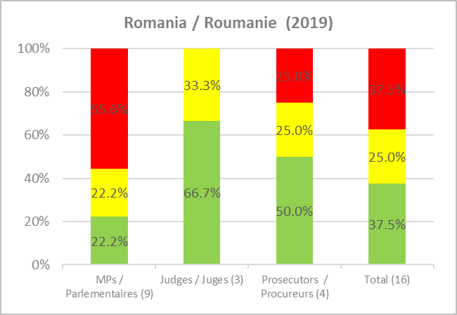

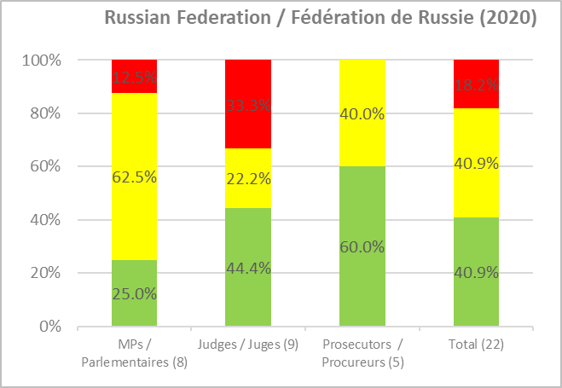

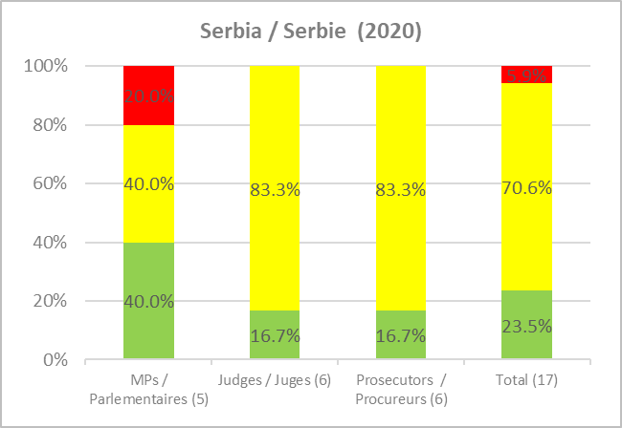

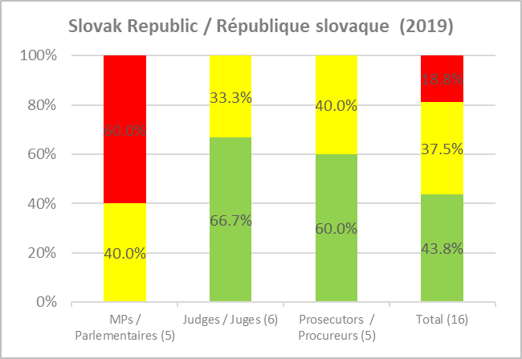

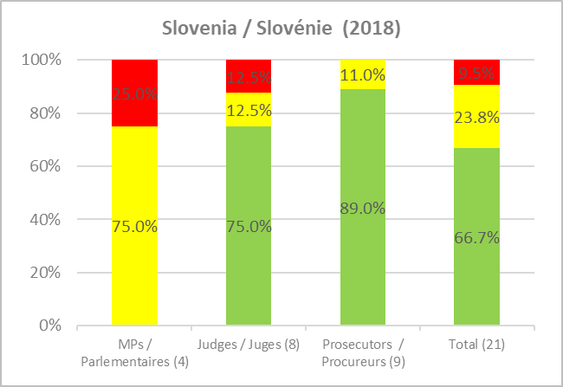

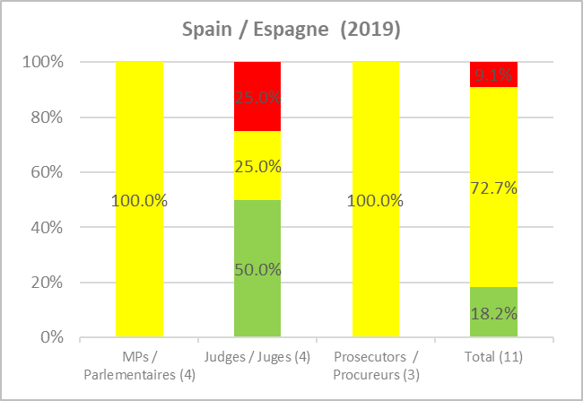

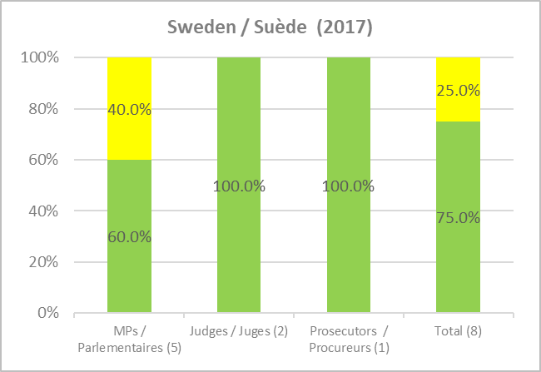

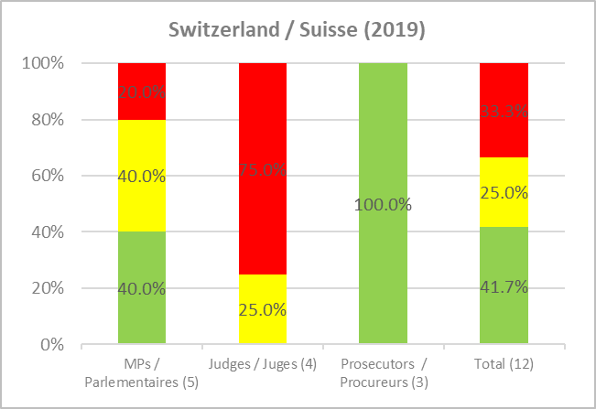

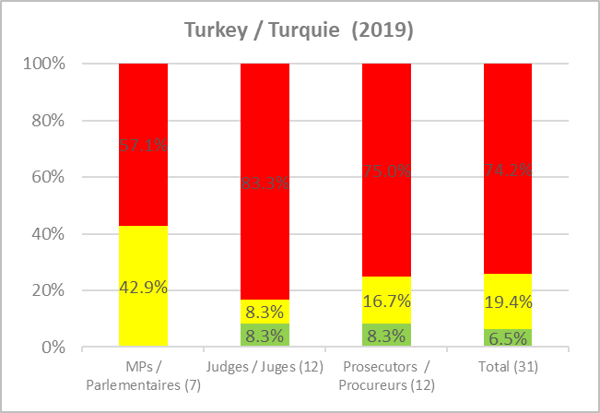

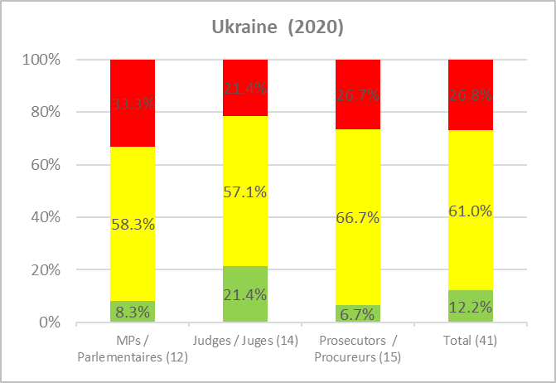

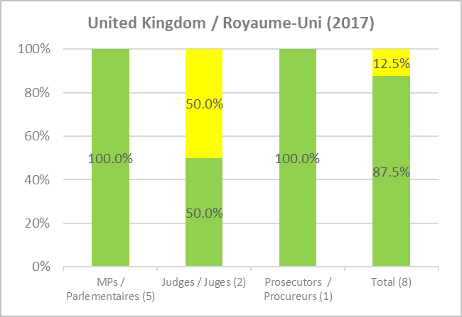

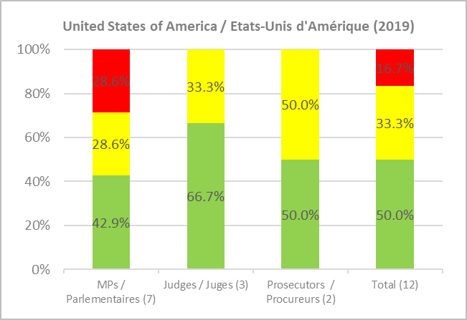

Appendix 3 - 5th Round Implementation Statistics
Statistics covering all assessments made public by end 2020 in this round - 3 member states

 | Implemented |  | Partly implemented |  | Not implemented
 | Mise en œuvre |  | Partiellement mise en œuvre |  | Non mise en œuvre

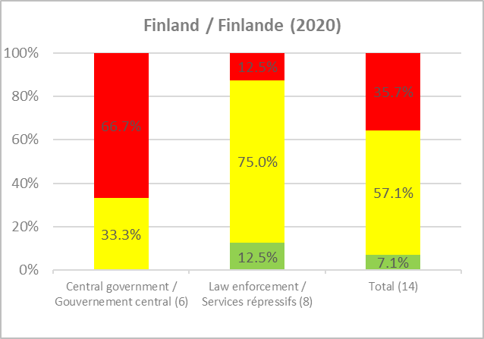

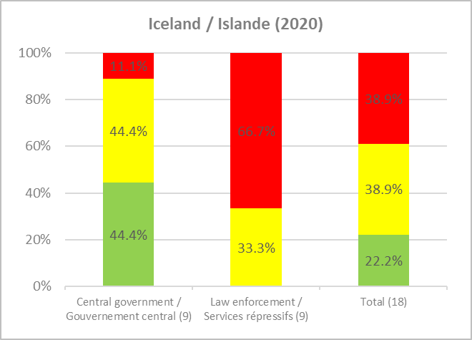

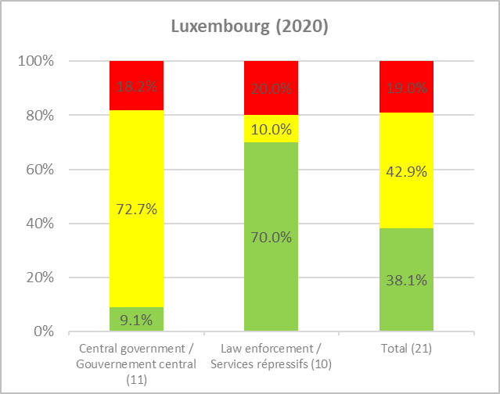

Appendix 4 - Core Programme

On-site evaluation visits in 2020
- None due to the COVID-19 pandemic

Meetings in 2020
GRECO Plenary
- GRECO 85 (21-25 September)
- GRECO 86 (26-30 October)
GRECO Bureau
- Bureau 89 (21 February)
- Bureau 90 (2 July)
- Bureau 91 (8 September)
- Bureau 92 (15 October)
- Bureau 93 (10 December)
GRECO Statutory Committee
- 27th Meeting – exceptional meeting (14 February)
- Approval Budget 2021 – by written procedure (15 October)

Evaluation reports adopted in 2020
5th Evaluation Round
- Albania
- Germany
- Norway
4th Evaluation Round
- Belarus
- Liechtenstein
- San Marino
Rule 34 – ad hoc procedure in exceptional circumstances
- Ad hoc (Rule 34) report on Greece – follow-up report

Compliance reports adopted in 2020
5th Evaluation Round compliance procedure
- Finland, Iceland, Latvia, Luxembourg, Slovenia – procedures on-going
4th Evaluation Round compliance procedure
- Croatia, Cyprus, Greece – procedures on-going
- Albania – procedure closed
Rule 32 – Globally unsatisfactory: non-compliance procedure
- Andorra, Bosnia and Herzegovina, Republic of Moldova, Serbia – procedures opened
- Austria, Hungary, Luxembourg, Turkey – procedures maintained
- Azerbaijan, France, Ireland, Latvia, North Macedonia, Slovak Republic – procedures closed
3rd Evaluation Round compliance procedure
- Bosnia and Herzegovina – procedure on-going
- Liechtenstein, San Marino, Turkey – procedures closed
Rule 32 - Globally unsatisfactory: non-compliance procedure
- Belarus – procedure maintained

Appendix 5 - GRECO Delegations (at 17/12/2020)

GRECO MEMBER STATES/ETATS MEMBRES DU GRECO

ALBANIA/ALBANIE
Ms Adea PIRDENI (Head of delegation)  Deputy Minister  Ministry of Justice | Ms Najada SHUNDI  Ministry of Justice
Substitut/e  Mr Nino STRATI  Specialist  General Directorate of Policies in the field of Justice  Ministry of Justice | Substitut/e  Ms Suzana FRASHËRI  Head of Sector  Policies and Strategies in the field of Justice  Ministry of Justice
ANDORRA/ANDORRE
Mme Eva GARCIA LLUELLES (Chef de délégation)
Ministère de la Justice et de l’Intérieur
Relations et coopération internationales dans le domaine juridique
Substitut/e
Ms Aida Garnica Barco
Legal adviser
Ministry of Justice and Interior
ARMENIA/ARMENIE
Ms Kristinne GRIGORYAN (Head of delegation)  Deputy Minister of Justice | Ms Mariam GALSTYAN  Head of Anti-Corruption Policy Development and Monitoring Department  Ministry of Justice
Substitut/e  Mr Srbuhi GALYAN  Deputy Prosecutor General | Substitut/e  Mr Suren KRMOYAN  Adviser to the Deputy Prime Minister
AUSTRIA/AUTRICHE
Mr Christian MANQUET (Head of delegation)  Head of Department for Criminal Law  Ministry for Constitution, Deregulation, Reforms & Justice | Ms Caroline BACHER  Public Prosecutor  Ministry for Constitution, Deregulation, Reforms & Justice
Substitut/e  Ms Verena WESSELY  Head of Unit 2.3 International Cooperation  Federal Bureau of Anti-Corruption  Federal Ministry of the Interior | Substitut/e  Ms Evelyn DOJNIK  Unit 2.3 International Instruments and Cooperation  Bureau of Anti-Corruption  Ministry of the Interior
AZERBAIJAN/AZERBAIDJAN
Mr Kamal JAFAROV (Head of delegation)  Member of Parliament  Member of State Policy and Legal Building Committee of Parliament | Mr Elnur MUSAYEV  Head of the Department of Extrajudicial Proceedings  General Prosecutor's Office
Substitut/e  Mr Emin NASIBOV  Senior Adviser  Department on work with law enforcement agencies  President’s Office | Substitut/e  Mr Sabuhi ALIYEV  Head of Preventive Department  Anti-Corruption Department  General Prosecutor’s Office

BELARUS
Mr Uladzimir KHOMICH (Head of delegation)
Director
Research and Practical Centre for Problems of Reinforcing Law and Order
General Prosecutor’s Office
Substitut/e  Ms Hanna KARABELNIKAVA  Associate Director  Research and Practical Centre for Problems of Reinforcing Law and Order  General Prosecutor’s Office | Substitut/e  Mr Igor SEVRUK  Head of Department  Supervision over the National Investigative Committee  General Prosecutor's Office
BELGIUM/BELGIQUE
M. Ricardo PARRONDO RAMOS (Chef de délégation)  Attaché au Service de la Politique Criminelle  Direction générale Législation, Libertés et Droits Fondamentaux  Service Public Fédéral Justice | M. Marc VAN DER HULST  Secrétaire Général Adjoint  Parlement fédéral
Substitut/e
M. Carl PIRON
Attaché au Service de la Politique Criminelle
DG Législation, Libertés et Droits Fondamentaux
Service Public Fédéral Justice (SPF Justice)
BOSNIA AND HERZEGOVINA/BOSNIE-HERZEGOVINE
Mr Adnan DLAKIĆ (Head of delegation)  Expert Adviser for Combating Corruption  Section for Combating Organized Crime & Corruption  Ministry of Security | Mr Nenad EŠPEK  Expert Associate for Combating crime committed through information and communication technologies and copyright protection  Section for Combating Organized Crime & Corruption  Ministry of Security
BULGARIA/BULGARIE
Mr Georgi RUPCHEV (Head of delegation)
Counsellor, Justice Unit
Permanent Representation of Bulgaria to the EU
Substitut/e
Mr Florian FLOROV
Chief Expert
Directorate of International Legal Cooperation and European Affairs
Ministry of Justice
CROATIA/CROATIE
Mr Marin MRČELA  President of GRECO / Président du GRECO  Vice-President of the Supreme Court | Mr Dražen JELENIĆ (Head of delegation)  Deputy State Attorney General
Substitut/e  Mr Davor DUBRAVICA  Magistrate  Municipal Court in Zadar | Substitut/e  Mr Krěsimir SIKAVICA  Head of Sector  Criminal Intelligence Sector  Criminal Police Directorate  General Police Directorate  Ministry of the Interior

CYPRUS/CHYPRE
Ms Alexia KALISPERA (Head of delegation)  Counsel of the Republic A’  The Law Office of the Republic | Ms Rena PAPAETI-HADJICOSTA  Attorney of the Republic  The Law Office of the Republic
Substitut/e
Ms Theodora PIPERI-CHRISTODOULOU
Counsel of the Republic A’
The Law Office of the Republic
CZECH REPUBLIC/REPUBLIQUE TCHEQUE
Ms Helena KLIMA LIŠUCHOVÁ (Head of delegation)  Junior Deputy Minister in charge of  International Affairs  Ministry of Justice | Ms Johana TREŠLOVÁ  Senior Ministerial Counsellor  Conflict of Interest and Anti-Corruption Department  Ministry of Justice
Substitut/e
Mr Matej BLAŽEK
Senior Ministerial Counsellor
Conflict of Interest and Anti-Corruption Department
Ministry of Justice
DENMARK/DANEMARK
Mr Anders Dyrvig RECHENDORFF (Head of Delegation)
Senior Prosecutor
State Prosecutor for Serious Economic and International Crime
International Unit
Substitut/e  Mr Andreas LAURSEN  Senior Prosecutor  State Prosecutor for Serious Economic and International Crime | Substitut/e  Mr Jacob Gøtze PEDERSEN  Chief Legal Advisor  State Prosecutor for Serious Economic and International Crime
ESTONIA/ESTONIE
Ms Mari-Liis SÖÖT (Head of delegation)  Head of Analysis Division  Criminal Policy Department  Ministry of Justice  International Unit | Ms Kätlin-Chris KRUUSMAA  Advisor, Analysis Division  Criminal Policy Department  Ministry of Justice
Substitut/e
Ms Anu KÄRTNER
Advisor
Anti-Corruption Select Committee
Chancellery of the Riigikogu (parliament)
FINLAND/FINLANDE
Mr Juha KERÄNEN (Head of delegation)  Ministerial Adviser  Department for Criminal Policy and Criminal Law  Ministry of Justice | Mr Jouko HUHTAMÄKI  Ministerial Adviser  Police department  Ministry of the Interior
Substitut/e  Mr Juuso OILINKI  Senior Specialist  Department of Criminal Policy and Criminal Law  Ministry of Justice | Substitut/e  Ms Venla MÄNTYSALO  Senior Specialist  Department for Criminal Policy and Criminal Law  Ministry of Justice

FRANCE
M. Vincent FILHOL (Chef de délégation)
Chargé de mission pour les affaires civiles et pénales internationales auprès du directeur des affaires juridiques
Ministère de l’Europe et des affaires étrangères
Direction des affaires juridiques
Substitut/e  Mme Sophie LACOTE  Cheffe de bureau  Bureau du droit économique, financier et social, de l’environnement et de la santé publique  Direction des affaires criminelles et des grâces  Ministère de la Justice | Substitut/e  Mme Izadora ZUBEK  Chargé de mission adjointe à l’action internationale  Agence française anticorruption (AFA)
M. Michel GAUTHIER
Avocat Général près la Cour de cassation de Paris honoraire
Président d’Honneur du GRECO /
Honorary President of GRECO
GEORGIA/GEORGIE
Mr Zurab SANIKIDZE (Head of delegation)  Chair  Public Service Development Agency  Ministry of Justice | Ms Tamar ROSTIASHVILI  Director  Analytical Department of the Ministry of Justice (Secretariat of the Anti-Corruption Council)
Substitut/e  Ms Pelagia MAKHAURI  Deputy Director  Analytical Department of the Ministry of Justice (Secretariat of the Anti-Corruption Council) | Substitut/e  Ms Gulisa KAKHNIASHVILI  First Category Chief Specialist  Analytical Department of the Ministry of Justice (Secretariat of the Anti-Corruption Council)
GERMANY/ALLEMAGNE
Mr Markus BUSCH (Head of delegation)  Head of Division  Economic, Computer, Corruption-related and  Environmental Crime Division  Federal Ministry of Justice and Consumer Protection | Ms Sabrina WINKLER  Legal Officer  Division II A 4 (Economic, Computer, Corruption-related and Environmental Crime)  Federal Ministry of Justice and Consumer Protection
Substitut/e  Ms Silvia SPÄTH  Legal Officer  Integrity, Corruption prevention and Sponsoring Division  Federal Ministry of the Interior, Building and Community | Substitut/e  Mr David AYDINTAN  Legal Advisor  Division PM 1 (Remuneration of Members)  Deutscher Bundestag- Verwaltung –
GREECE/GRECE
Ms Maria GAVOUNELI (Head of delegation)  Professor of International Law  National & Kapodistrian University of Athens  Faculty of Law  Management Board, National Transparency Authority | Ms Panagiota VATIKALOU  Bureau Member / Membre du Bureau  Presiding Judge in the First Instance Court of Athens
Substitut/e  Mr Panagiotis KAOURAS  Inspector Auditor  National Transparency Authority  Inspections and Audits Unit | Substitut/e  Mr Dimosthenis STINGAS  Judge by the Court of Appeal in Athens  Justice counsellor at the Permanent Representation of Greece to the EU

HUNGARY/HONGRIE
Mr Bálint VARRÓ (acting Head of delegation)  Legal and anti-corruption expert  Department of European Cooperation  Ministry of the Interior | Ms Magdolna CSABA  JHA expert  Department of European Cooperation  Ministry of the Interior
ICELAND/ISLANDE
Mr Björn THORVALDSSON (Head of delegation)  Public Prosecutor  Special Prosecutors Office | Mr Helgi Magnús GUNNARSSON  Deputy Director of Public Prosecution  Office of the Director of Public Prosecution
Substitut/e
Mr Pall THORHALLSSON
Director - Department of Legislative Affairs
Prime Minister’s Office
IRELAND/IRLANDE
Ms Eileen LEAHY (Head of Delegation)  Criminal Justice Policy  Department of Justice and Equality | Ms Mary AUSTIN  Expenditure Management, EU Policy and Audit  Department of Public Expenditure and Reform
Substitut/e | Substitut/e  Ms Joyce NOLAN  Government Reform Unit  Department of Public Expenditure and Reform
ITALY/ITALIE
M. Raffaele PICCIRILLO (Chef de délégation)  Chef du Cabinet du Ministre de la Justice | M. Giuseppe BUSIA  Président  Autorité Nationale Anti-Corruption (ANAC)
Substitut/e  Ms Emma RIZZATO  Magistrate  Ministry of Justice | Substitut/e  Mme Laura VALLI  Conseillère  Autorité Nationale Anti-Corruption (ANAC)
KAZAKHSTAN
Mr Olzhas BEKTENOV (Head of delegation)  First Deputy Chairman  Anti-Corruption Agency | Ms Leila IYLDYZ  Adviser to Chairman  Anti-Corruption Agency
Substitut/e  Mr Nurlan ZHAXIMBETOV  Head of Human Resources Department  Anti-Corruption Agency | Substitut/e  Ms Rauan SHAKRATOVA  Chief Consultant, Partnership Department  Anti-Corruption Agency
LATVIA/LETTONIE
Mr Jēkabs STRAUME (Head of delegation)  Director  Corruption Prevention and Combating Bureau (KNAB) | Ms Sintija HELVIGA-EIHVALDE  Head of the Strategic Analysis Division  Corruption Prevention and Combating Bureau (KNAB)  Department of Strategy
Substitut/e
Ms Diāna KAZINA
Chief Inspector
Strategic Analysis Division
Department of Strategy
Corruption Prevention and Combating Bureau (KNAB)

LIECHTENSTEIN
Ms Helen LOREZ (Head of delegation)  Deputy Permanent Representative  Office for Foreign Affairs | Mr Harald OBERDORFER  Lawyer | Ressort Justiz
Substitut/e  Mr Claudio NARDI  Office for Foreign Affairs | Substitut/e  Mr Michael JEHLE  Judge | Landgericht
LITHUANIA/LITUANIE
… (Head of Delegation) | Ms Agne VERSELYTE  Senior Adviser  International Law Group  Ministry of Justice
Substitut/e
Ms Živilė ŠADIANEC
Chief Specialist
International Cooperation Division
Special Investigation Service
LUXEMBOURG
M. David LENTZ (Chef de délégation)  Procureur d’Etat adjoint | M. Laurent THYES  Conseiller de Direction adjoint  Ministère de la Justice
Substitut/e  M. Georges KEIPES  Attaché  Ministère de la Justice  Direction des affaires pénales et judiciaires | Substitut/e  Mme Cindy COUTINHO  Attachée  Ministère de la Justice  Direction des affaires pénales et judiciaires
MALTA/MALTE
Mr Kevin VALLETTA (Head of delegation)  Office of the Attorney General | Ms Victoria BUTTIGIEG  Attorney General  Office of the Attorney General
REPUBLIC OF MOLDOVA/REPUBLIQUE DE MOLDOVA
Mr Alexandru CLADCO (Head of delegation)  Prosecutor  Head of International Cooperation and European Integration  Department of the General Prosecutor’s Office | Mr Valeriu CUPCEA  Head of the International Cooperation Directorate  National Anti-corruption Centre
Substitut/e
Mme Cornelia VICLEANSCHI
Ancien Procureur
Bureau du Procureur Général
MONACO
M. Jean-Laurent RAVERA (Chef de délégation)  Chef de Service du Droit International, des Droits de l'Homme et des Libertés Fondamentales  Direction des Affaires Juridiques | Monsieur Yves STRICKLER  Professeur agrégé des Facultés de Droit  et membre du Haut Conseil de la Magistrature monégasque
Substitut/e  M. Jean-Marc GUALANDI  Conseiller Technique - SICCFIN  Service d’Information et de Contrôle sur les Circuits Financiers Département des Finances et de l’Economie | Substitut/e  M. Maxime MAILLET  Administrateur Principal  Direction des Services Judiciaires

MONTENEGRO
Mr Dušan DRAKIC (Head of Delegation)  Head of Section  Agency for Prevention of Corruption | Ms Marina MICUNOVIC  Head of Section  Agency for Prevention of Corruption
Substitut/e  Ms Ivana MASANOVIC  Senior Advisor  Directorate for Judiciary  Department for Organisation of Justice  Ministry of Justice | Substitut/e  Mr Mladen TOMOVIC  Head of Section  Agency for Prevention of Corruption
NETHERLANDS/PAYS-BAS
Ms Marja van der WERF (Head of delegation)  Senior Policy Advisor  Ministry of the Interior and Kingdom Relations | Ms Quirien VAN STRAELEN  Senior Policy Advisor  Ministry of Justice and Security  Law Enforcement Department | Fraud Unit
Substitut/e  Ms Tessa Lansbergen  Policy Advisor  Ministry of the Interior and Kingdom Relations  Department for Civil Service | Substitut/e  Ms Kirsten BOSCH  Policy Advisor  Ministry of Justice and Security  Law Enforcement Department | Fraud Unit
NORTH MACEDONIA/MACEDOINE DU NORD
Ms Ana PAVLOVSKA DANEVA (Head of delegation)  Professor - Iustinianus Primus Faculty of Law  Ss. Cyril and Methodius University | Ms Biljana IVANOVSKA  President  State Commission for the Prevention of Corruption
Substitut/e  Ms Elena SAZDOV  Advisor  Ministry of Justice | Substitut/e  Mr Vladimir GEORGIEV  Commissioner  State Commission for the Prevention of Corruption
NORWAY/NORVEGE
Ms Mona RANSEDOKKEN (Head of delegation)  Senior Adviser  Ministry of Justice and Public Security  Police Department  International Section | Mr Jens-Oscar NERGARD  Senior Adviser  Ministry of Local Government and Modernisation
Substitut/e  Ms Siri Eide KROSBY  Senior adviser  Ministry of Justice and Public Security  Police Department, International section | Substitut/e  Mr Eivind SMITH  Professor Dr juris  Faculty of Law
POLAND/POLOGNE
Ms Katarzyna NASZCZYŃSKA (Head of Delegation)  Deputy Director- Judge  Legislation Department of Criminal Law  Ministry of Justice | Ms Alicja KLAMCZYNSKA  Chief specialist  European and International Criminal Law Division  Legislation Department of Criminal Law  Ministry of Justice

PORTUGAL
Mr Ricardo Lopes Dinis PEDRO (Head of delegation)  Legal Adviser  Directorate General for Justice Policy  International Affairs Department  Ministry of Justice | Mr João Pedro Arsénio de Oliveira  European Affairs Coordinator  Directorate General for Justice Policy  International Affairs Department  Ministry of Justice
Substitut/e
Ms Sara Nunes de Almeida
European Affairs Sub-Coordinator
Directorate General for Justice Policy
International Affairs Department
Ministry of Justice
ROMANIA/ROUMANIE
Mr Sorin TANASE (Head of delegation)  Deputy director  Directorate for Crime Prevention  Ministry of Justice | Ms Anca JURMA  Chief Prosecutor  International Cooperation Service  National Anticorruption Directorate  Prosecutors’ Office attached to the High Court of Cassation and Justice
Substitut/e  Ms Anca Luminiţa STROE  Legal Counsellor  Directorate for Crime Prevention  Ministry of Justice | Substitut/e  Mr Nicolae SOLOMON  Prosecutor  Member of the Superior Council of Magistracy
RUSSIAN FEDERATION/FEDERATION DE RUSSIE
Mr Aleksandr BUKSMAN (Head of delegation)  First Deputy Prosecutor General  Prosecutor General’s Office | Mr Aslan YUSUFOV  Bureau Member / Membre du Bureau  Deputy Head of Directorate  Head of Section of supervision over implementation of Anti-corruption legislation Prosecutor General’s Office
Substitut/e  Mr Alexander ANIKIN  Deputy Head of the Presidential Anti-Corruption Directorate | Substitut/e  Mr Evgeny KUZMIN  Head of Department of Analytical, Organisational and Methodological Support  Anti-corruption Office
SAN MARINO/SAINT-MARIN
M. Eros GASPERONI (Chef de délégation)  Conseiller  Ministère des Affaires étrangères et politiques | Mr Manuel CANTI  Director of the Civil Service Department
Substitut/e  Mr Stefano PALMUCCI  Official at the Department of Foreign Affairs | Substitut/e  Ms Marina MARFORI  State Lawyers’ Office  Expert in Legislative Studies
SERBIA/SERBIE
Mr Dragan SIKIMIC (Head of delegation)  Director  The Agency for Prevention of Corruption | Mr Jovan COSIC  Assistant Minister at the Ministry of Justice
Substitut/e  Ms Bojana SMARTEK  Department for Foreign Affairs and Strategic Development  The Agency for Prevention of Corruption | Substitut/e  Ms Katarina NIKOLIC  Advisor on International Cooperation matters  Ministry of Justice
SLOVAK REPUBLIC/REPUBLIQUE SLOVAQUE
Ms Zuzana ŠTOFOVÁ (Head of delegation)  International Law Department  Ministry of Justice | Ms Alexandra KAPISOVSKA  Director of Prevention Corruption Department  Prevention Corruption and Crisis Management Section
Substitut/e
Ms Lívia TYMKOVÁ
International Law Department
Ministry of Justice
SLOVENIA/SLOVENIE
Ms Vita HABJAN BARBORIČ (Head of delegation)
Bureau Member / Gender Equality Rapporteur
Head of the Centre for Corruption Prevention and the Integrity of Public Office
Commission for the Prevention of Corruption
Substitut/e
Mr. Robert ŠUMI
Chief Commissioner
Commission for the Prevention of Corruption
SPAIN/ESPAGNE
Ms Ana ANDRES BALLESTEROS (Head of delegation)  Head of Unit  Unit for Justice Affairs in the EU and International Organizations and Human Rights  Ministry of Justice | Mr Rafael VAILLO RAMOS  Technical Adviser  DG for International Cooperation  Ministry of Justice
Substitut/e  Mr Rafael BLAZQUEZ  Technical Counsellor  DG for International Cooperation  Ministry of Justice | Substitut(e)
SWEDEN/SUEDE
Ms Monika OLSSON (Head of delegation)  Vice-President of GRECO/Vice-présidente  du GRECO  Director  Division for Criminal Law  Ministry of Justice | Mr Mikael TOLLERZ  Director  Ministry of Justice
SWITZERLAND/SUISSE
M. Ernst GNAEGI (Chef de délégation)  Bureau Member / Membre du Bureau  Chef de l’unité du droit pénal international  Office fédéral de la Justice | M. Olivier GONIN  Conseiller scientifique  Unité du droit pénal international  Office fédéral de la justice
Substitut/e  M. Jacques RAYROUD  Procureur général suppléant  Ministère public de la Confédération | Substitut/e  M. Jean-Christophe GEISER  Avocat  Conseiller scientifique  Office fédéral de la justice

TURKEY/TURQUIE
Mr Mustafa Tayip ÇİÇEK (Head of delegation)  Deputy Director General  Directorate General for International Relations  and EU Affairs  Ministry of Justice | Mr Selahattin DOĞAN  Chief of Department  Directorate General for International Relations  and EU Affairs  Ministry of Justice
Substitut/e  Mr Mehmet Soner ÖZOĞLU  Rapporteur Judge  Directorate General for International Relations  and EU Affairs  Ministry of Justice | Substitut/e  Mr Yahya Kemal AKSU  Rapporteur Judge  Directorate General for International Relations  and EU Affairs  Ministry of Justice
UKRAINE
Mr Mykhaylo BUROMENSKIY (Head of delegation)  Member of the National Council for  Anti-corruption Policy | Mr Ruslan RIABOSHAPKA  Deputy Head of the Office of the President
Substitut/e
Ms Anastasia KRASNOSILSKA
Expert of the NGO “Anti-corruption Action Center”
UNITED/KINGDOM
Mr David MEYER (Head of delegation)  Bureau Member / Membre du Bureau  Head of International Relations  International and Rights Directorate  Ministry of Justice | Ms Fariha KHAN  Senior Policy Adviser  International and Rights Directorate  Ministry of Justice
Substitut/e
Mr Alvin AUBEELUCK
International and Rights Directorate
Ministry of Justice
UNITED STATES OF AMERICA/ETATS-UNIS D’AMERIQUE
Ms Michelle MORALES (Head of delegation)  Deputy Director, Office of Policy and Legislation  U.S. Department of Justice, Criminal Division | Mr Kenneth HARRIS  Senior Counsellor for the European Union  U.S Department of Justice, Criminal Division
Substitut/e  Mr Jonathan WROBLEWSKI  Director, Office of Policy and Legislation  U.S. Department of Justice, Criminal Division | Substitut/e  Ms Yelena ZERU  Foreign Affairs Officer  Bureau of European and Eurasian Affairs  Office of Policy and Global Issues  Rule of Law/Anti-corruption Lead  U.S Department of Stat
COUNCIL OF EUROPE/CONSEIL DE L’EUROPE

GRECO’S STATUTORY COMMITTEE/COMITE STATUTAIRE DU GRECO
Mr Emil RUFFER, Permanent Representative of the Czech Republic to the Council of Europe
President of GRECO’s Statutory Committee
PARLIAMENTARY ASSEMBLY OF THE COUNCIL OF EUROPE/
ASSEMBLEE PARLEMENTAIRE DU CONSEIL DE L’EUROPE
Mr Pere LÓPEZ  (Andorra, Socialist Group) | Mr Sergiy VLASENKO  (Ukraine, European People’s Party Group

EUROPEAN COMMITTEE ON LEGAL COOPERATION/COMITE EUROPEEN DE COOPERATION JURIDIQUE (CDCJ)
No nomination | Pas de nomination
EUROPEAN COMMITTEE ON CRIME PROBLEMS/COMITE EUROPÉEN POUR LES PROBLÈMES CRIMINELS (CDPC)
No nomination | Pas de nomination
COUNCIL OF EUROPE DEVELOPMENT BANK/BANQUE DE DEVELOPPEMENT DU CONSEIL DE L’EUROPE (CEB)
Ms Katherine DELIKOURA, Chief Compliance Officer
OBSERVERS/OBSERVATEURS

ORGANISATION FOR ECONOMIC CO-OPERATION AND DEVELOPMENT (OECD)/
ORGANISATION DE COOPERATION ET DE DEVELOPPEMENT ECONOMIQUES (OCDE)
M. Patrick MOULETTE  Division de Lutte contre la Corruption  Direction des Affaires Financières et des Entreprises | Ms Olga SAVRAN  Anti-Corruption Network for Transition Economies  within Anti-Corruption Division
Substitut/e  Ms France CHAIN  Anti-Corruption Division  Directorate for Financial and Enterprise Affairs | Substitut/e  Ms Tanya KHAVANSKA  Anti-Corruption Division  Directorate for Financial and Enterprise Affairs
UNITED NATIONS, REPRESENTED BY THE UN OFFICE ON DRUGS AND CRIME (UNODC)/
NATIONS UNIES, REPRESENTEES PAR L’OFFICE DES NATIONS UNIES CONTRE LA DROGUE ET LE CRIME (ONUDC)
Ms Brigitte STROBEL-SHAW  Chief, Corruption and Economic Crime Branch | Ms Stefanie HOLLING  Corruption and Economic Crime Branch
INTERNATIONAL ANTI_CORUPTION ACADEMY/
ACADEMIE INTERNATIONALE DE LUTTE CONTRE LA CORRUPTION (IACA)
Ms Christiane POHN-HUFNAGL  Head of General Services | Mr Jaroslaw PIETRUSIEWICZ  Head of External Relations & Protocol
Substitut/e
Ms Simona MARIN
Deputy Head of External Relations & Protocol
ORGANISATION OF AMERICAN STATES (OAS)/ORGANISATION DES ETATS AMERICAINS (OEA)
Mr Jorge GARCIA-GONZALES
Director of the Department of Legal Cooperation
Secretariat for Legal Affairs
INTERNATIONAL INSTITUTE FOR DEMOCRACY AND ELECOTRAL ASSISTANCE/
INSTITUT INTERNATIONAL POUR LA DEMOCRATIE ET L’ASSISTANCE ELECTORALE (International IDEA)
Mr Sam VAN DER STAAK
Senior Programme Manager
OSCE OFFICE FOR DEMOCRATIC INSTITUTIONS AND HUMAN RIGHTS (OSCE/ODIHR)/
BUREAU DES INSTITUTIONS DEMOCRATIQUES ET DES DROITS DE L’HOMME DE L’OSCE (OSCE/BIDDH)
Mr Jacopo LEONE  Chief of Democratic Governance and Gender Unit | Mr Radivoje GRUJIC  Associate Democratic Governance Officer

EUROPEAN UNION/UNION EUROPEENNE
Ms Floriana SIPALA  Head of Unit  European Commission  DG Migration and Home Affairs  Organised Crime and Drugs Policy Unit | Ms Anitta M. HIPPER  Team leader Anti-Corruption  European Commission  DG Migration and Home Affairs  Directorate D – Law Enforcement and Security  Unit D5 - Organised Crime and Drugs Policy
Substitut/e
Mr Per IBOLD
Deputy, Minister Counsellor
European Union Delegation to the Council of Europe

Appendix 6 – Working Together for Greater Impact

European Union (EU)
- Meetings with the EU Delegation in GRECO and members of the Cabinet of Commissioner Reynders (Brussels, 17 January) - Secretariat
- Democracy, Rule of Law and Fundamental Rights Monitoring Group (DRFMG) of the LIBE Committee of the European Parliament (2 April, 18 June and 28 August) - Secretariat
- EU Fundamental Rights Agency (FRA) Advisory Board of the EU Fundamental Rights Information System (EFRIS) (15 October) - Secretariat
- Exchange of views with the European Council Working Party on Enlargement and Countries Negotiating Accession to the EU (COELA) (19 May) – President
- European Parliament webinars for Western Balkans and Eastern Partnership parliaments Anti-corruption and the Covid-19 Crisis (1 and 3 July) - Secretariat
- Article 36 Committee (CATS) meetings (15 June and 8 December) – Secretariat

International Partnership against Corruption in Sport (IPACS)
- IPACS Core Group meetings (24 February, 17 April, 6 May, 8 June, 27 October and 12 November) - Secretariat
- IPACS Task Force 2 Meeting (6 October) - Secretariat
- IPACS Steering Committee (16 November) – Vice-President

Organisation for Economic Co-operation and Development (OECD)
- Expert consultations on the OECD Public Integrity Indicators (26 May) - Secretariat
- Meetings of the Working party of senior public integrity officials - SPIO (25-26 May, 30 November) - Secretariat
- Meetings of the Working Group on Bribery in International Business Transactions (WGB) (12-15 October and 8-11 December) – Secretariat

Organisation for Security and Co-operation in Europe/Office for Democratic Institutions and Human Rights (OSCE/ODIHR)
- 2nd Preparatory meeting of the 28th OSCE Economic and Environmental Forum (EEF) under the Albanian chairmanship of the OSCE (15 June) – President
- Albanian OSCE Chairmanship conference Good Governance and the Fight against Corruption in the Digital Era: Strengthening the Principles of Transparency, Integrity and Accountability, (6 July) – President
- ODIHR 6th expert Round Table on the Rule of Law in Poland (11 September) - Secretariat
- OSCE Parliamentary Web Dialogue Parliamentarians & Journalists: Partners Against Corruption (14 October) - Secretariat
- ODIHR 7th expert Round Table on the Rule of Law in Poland (16 December) – Secretariat

United Nations
- Global Judicial Integrity Network (Doha, 24-27 February) – President
- United Nations Convention against Corruption (UNCAC) 11th Session of the Implementation Review Group (29 June) – Secretariat
- UNCAC 1st Resumed 11th Session of the Implementation Review Group and Open-ended Intergovernmental Working Group on the Prevention of Corruption (31 August – 2 September) - Secretariat
- UNCAC 2nd resumed 11th Session of the Implementation Review Group (16-18 November) – Secretariat
- 1st and 2nd Intersessional meetings of the Conference of the States Parties to the United Nations Convention against Corruption on the preparations for the Special Session of the General Assembly against corruption (UNGASS) (2-4 September and 19-20 November) – Secretariat

Other contacts
- Office of the Ombudsman, Basque Country (Spain) Conference on GRECO public sector integrity standards (Bilbao, 10 February) – GRECO Secretariat jointly with the President of the OECD Working Group on Bribery in International Business Transactions
- Working visit of Mr Robert GELLI, Minister of Justice of Monaco (26 March) - Secretariat
- Euronews and other media interviews (8 June) – President
- Contact meeting with FIFA officials (8 July) – Secretariat
- Meetings with GRECO counterparts in the UNODC and OECD Working Group on Bribery in International Business Transactions (WGB) (7 April and 15 July) – Secretariat
- Briefing and Q&A on GRECO for representatives of Council of Europe member and observer states, and international institutions based in Serbia (8 July) - Secretariat
- Meeting with GRECO counterparts in the UNODC, OECD (WGB) and the OAS (24 August) - Secretariat
- Regional Anti-Corruption Initiative (RAI) School for Junior Anti-Corruption Practitioners from South-East Europe - webinar (5 October) – President
- Meeting with Mr Anuarbek AKHMETOV, Consul General of the Republic of Kazakhstan in Strasbourg, Representative of Kazakhstan to the Council of Europe (6 October) - Secretariat
- 3rd FIFA Compliance Summit (12 October) - Secretariat
- Government of Albania high-Level conference Strengthening integrity and fighting Corruption: Latest achievements in Albania (13 October) – Secretariat
- Institute for Compliance, Criminal Compliance and Anti-money laundering (ICCrA) Working Group on Compliance Guidelines (Zagreb, 22 October) – President
- Transparency International (TI) 19th International Anti-Corruption Conference (IACC) hosted by the Republic of Korea (30 November – 5 December) | GRECO, OECD, OSCE/ODIHR, International IDEA workshop Towards Transparent Politics: Corruption Prevention in Parliaments and Central Governments - Vita HABJAN BARBORIČ, GRECO Bureau member (Head of Delegation, Slovenia), GRECO Evaluator Yves-Marie DOUBLET (France), Jan KLEIJSSEN, Director, Information Society – Action against Crime, Council of Europe | U4 Anti-Corruption Centre workshop Are Public-Private Networks the Solution for Improving Integrity at the Sector Level? – Secretariat
- BRICS Expert Round Table on Anti-Corruption Education and Training (1 December) - Aslan YUSUFOV, GRECO Bureau member (Russian Federation)
- Serbian Anti-Corruption Authority Conference on activities and cooperation of corruption prevention authorities in the new global circumstances (8 December) – President
- Parliament of Croatia How codes of ethics can help in parliamentary work (9 December) – President
- Statement by GRECO’s President No quarter to corruption in healthcare issued on the occasion of International Anti-corruption Day (9 December)
- TI Hungary end of year event– keynote address (9 December) - President
- Ministry of Justice of Croatia Roundtable on codes of conduct for parliamentarians (11 December) - President

Council of Europe
- Study visit to the Council of Europe – Judges from Sweden (Strasbourg, 22 January) – Secretariat
- Study visit to the Council of Europe - EEA/Norway Grants Financial Mechanism Office trainees (Strasbourg, 5 February) - Secretariat
- Courtesy visit with the Secretary General of the Council of Europe (Strasbourg, 17 March) - President
- GRECO/Council of Europe Academic Network (CEAN) webinar to present the Guidelines on managing corruption risks in the context of COVID-19 issued by GRECO’s President (14 May) - President
- Exchange of views and presentation of GRECO’s General Activity Report - 2019 to the Committee of Ministers (27 May) –President

- Press launch of GRECO’s General Activity Report - 2019 (3 June) - President
- Videoconference of the Greek Chairmanship of the Committee of Ministers Protection of human life and public health in the context of a pandemic (17 June) – Aslan YUSUFOV, GRECO Bureau member (Russian Federation)
- 8th Annual meeting of the Secretary General with the Presidents and Secretaries of the Monitoring and Advisory Bodies of the Council of Europe (29 June) – President
- Economic Crime and Cooperation Division online forum Controlling Corruption Risks in Crises Settings (9 December) – Vita HABJAN BARBORIČ, GRECO Bureau member (Head of Delegation, Slovenia)

Appendix 7 - GRECO Secretariat
Directorate General Human Rights and Rule of Law,
Information Society - Action against Crime Directorate

Gianluca ESPOSITO, Executive Secretary of GRECO, Head of the Action against Crime Department
Heather ROSCOW SCHMITT, Personal assistant to the Executive Secretary and Head of Department
Björn JANSON, Deputy Executive Secretary of GRECO

Senior legal advisors
Laura SANZ-LEVIA
Sophie MEUDAL-LEENDERS
Lioubov SAMOKHINA
Tania VAN DIJK
Gerald DUNN
Roman CHLAPAK
David DOLIDZE
Stéphane LEYENBERGER

Central office
Penelope PREBENSEN
Marie-Rose PREVOST
Diana FRECHOSO

MEMBERSHIP

GRECO’s membership comprises the 47 Council of Europe member states, Belarus, Kazakhstan and the United States of America and spans three continents.

Members (50) by date of accession
Belgium, Bulgaria, Cyprus, Estonia, Finland, France, Germany, Greece, Iceland, Ireland, Lithuania, Luxembourg, Romania, the Slovak Republic, Slovenia, Spain, Sweden (founding states - 1 May 1999)

Poland (date of accession: 20 May 1999), Hungary (9 July 1999), Georgia (16 September 1999), United Kingdom (18 September 1999), Bosnia and Herzegovina (25 February 2000), Latvia (27 July 2000), Denmark (3 August 2000), United States of America (20 September 2000), North Macedonia (7 October 2000), Croatia (2 December 2000), Norway (6 January 2001), Albania (27 April 2001), Malta (11 May 2001), Republic of Moldova (28 June 2001), Netherlands (18 December 2001), Portugal (1 January 2002), Czech Republic (9 February 2002), Serbia (1 April 2003), Turkey (1 January 2004), Armenia (20 January 2004), Azerbaijan (1 June 2004), Andorra (28 January 2005), Ukraine (1 January 2006), Montenegro (6 June 2006), Switzerland (1 July 2006), Austria (1 December 2006), Russian Federation (1 February 2007), Italy (30 June 2007), Monaco (1 July 2007), Liechtenstein (1 January 2010), San Marino (13 August 2010), Belarus (1 July 2006 - effective participation as of 13 January 2011), Kazakhstan (1 January 2020).

At end 2020, the following countries were in the non-compliance procedure under the 4th round: Andorra, Armenia, Austria, Bosnia and Herzegovina, the Czech Republic, Denmark, Germany, Hungary, Luxembourg, Republic of Moldova, Monaco, Poland (including Rule 34), Portugal, Romania, Serbia and Turkey.
See http://www.coe.int/en/web/greco/greco-in-the-media
See https://www.coe.int/en/web/greco/evaluations
In this context, the term “constitutional set-up” is to be understood as meaning a country’s constitution, practice and specificities.
Administrative customs services and tax authorities are excluded from this evaluation.
Since 1 January 2021, Hanne JUNCHER is the new Executive Secretary of GRECO.
This appendix covers 46 member states assessed in the 4th Evaluation Round by end 2020. The statistics only take into account the situation recorded in reports made public by a member state by end 2020. The numbers in brackets refer to the number of recommendations issued under each category – when GRECO issued the same recommendation for 2 or 3 categories, the recommendation is counted twice or three times for the purpose of these statistics. The year refers to the year in which the most recent assessment was made public.
This appendix covers 3 member states assessed in the 5th Evaluation Round by end 2020. The statistics only take into account the situation recorded in reports made public by a member state by end 2020. The numbers in brackets refer to the number of recommendations issued under each category – when GRECO issued the same recommendation for 2 categories, the recommendation is counted twice for the purpose of these statistics. The year refers to the year in which the most recent assessment was made public.
Hanne JUNCHER was appointed Executive Secretary of GRECO and Head of the Action against Crime Department on 1 January 2021.

